Question of the Week: How many plants and flowers grow in the Foundation Stage garden? WB: 13.04.26

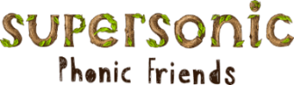  In Phonics we will be starting  Basics 4 – adjacent consonants  (e.g. hand, milk)  We will also be practising the following tricky words:  were, what, like, have  HFW: from, went, just, help, it’s children | Handwriting,  We will be continuing to practise writing Len’s Ladders 2.  r, n, m  We will be recognising which letter family the letters come from and saying the ditties as we practice! |   In Writing,  we will be using our new Basics 4 Phonic knowledge to write sentences. | Maths  In Maths, we will be continuing to practise Number Bonds to 10.  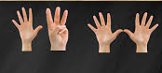
  Five Little Peas  Five little peas in a pea pod pressed.  One grew. Two grew.  So did all the rest.  They grew, and they grew,  And they did not stop,  Until one day the pod went POP!  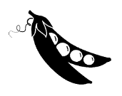 | Our topic is Nature Detectives – Growing  We will be reading The Tiny Seed, Jasper’s Beanstalk and The Enormous Turnip.  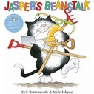  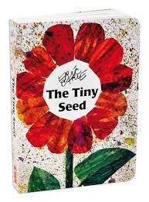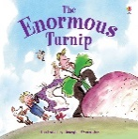  This week we will be learning to create a map and will be exploring the different flowers within our garden through observations.  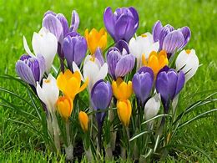  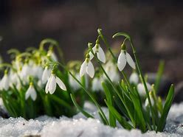  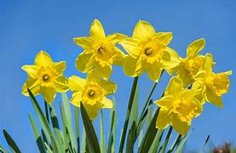 |  | Curious Question  Would you dare to pick up a beautiful flower? (But what if it was the last one in the world?)  

