English  This week we writing a recount based on ‘The Girl, the bear and the magic shoes’. | Maths  We will be looking at comparing and ordering numbers to 20. | PE  Our focus in PE in this half term will be multi-skills Please ensure your child has a full, named PE kit including joggers as we will sometimes be outside.
Music  We will be exploring musical sounds and how they can be changed focussing on timbre, dynamics and pitch. | Week beginning 19.1.26  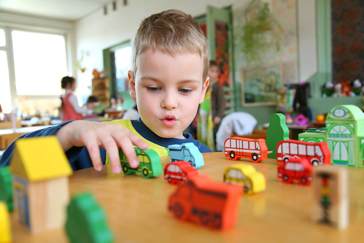 | Science  This week we will be testing materials to see which can make the best pair of trousers for the everywhere bear.
Poetry  We will be looking at classic Poems from our “Poetry Basket”.  This half term our poems are “Space” |  | Art  This half term we will be working on mixing of primary colours.
 | PSHE  This half term we are focusing on looking at feelings and how to regulate your own feelings. | History  This week we will start looking at a selection of new and old toys and comparing them and how we know they are old or new toys.
Phonics
We will be working through the choose to use sounds and tricky words.

