English  We will be doing some of our own independent pieces of writing. | Maths  We will be recapping work on numbers. | PE  Our focus in PE in this half term will be multi-skills Please ensure your child has a full, named PE kit including joggers as we will sometimes be outside.
Music  We will be exploring musical sounds and how they can be changed focussing on timbre, dynamics and pitch. | Week beginning 13.7.26  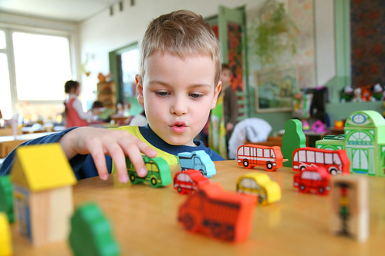 | Art  This half term our skill is sewing. We will be practicing threading a needle, and different types of stitches, towards making a final product.
Poetry  We will be looking at classic Poems from our “Poetry Basket”.  This half term our poems are “World” |  | Transition  We will be having our second transition morning this week where we will spend the morning in our new classes.
 | PSHE  Our topic this half term is all about diversity and communities. This week we will know that people can enjoy the same and different things. | History  This week we will be recapping everything we know about explorers.
Phonics
We will be starting spelling rules in our phonics lessons this half term.

