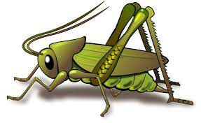
Summer 2 Week 1
Activities based on the interests of the children….
Our story  Our Core Text this week will be The Gingerbread Man .  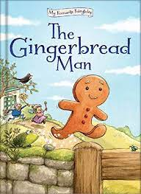  We will be thinking about other traditional tales that we have read and the use of repetative language.  We will be story telling using story maps. | Poetry basket    Our Poetry Basket Poem this week is;  Monkey Babies  Don’t leave your monkey baby sitting by a swamp.  A crocodile might eat him. Chomp. Chomp. Chomp.  Don’t leave your monkey baby sitting in the breeze.  A snake might wrap around him. Squeeze. Squeeze. Squeeze.  Don’t leave your monkey baby sitting on the track.  A lion might be lurking. Snack. Snack. Snack.  Keep your monkey baby high up in the trees,  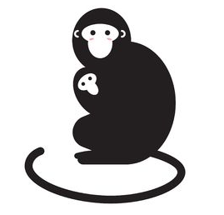  Feed him on bananas and pick off all his fleas. | Our rhymes  Our Number rhyme this week is ‘Baa Baa Black Sheep’  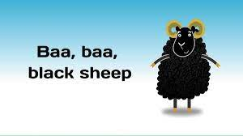  Our Number rhyme is ‘5 Little Monkey’s’  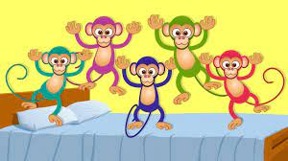
Maths  We will be consolidating all our number and maths skills this half term. This week we will also be looking at 2D and 3D shapes and finding them in our classroom.  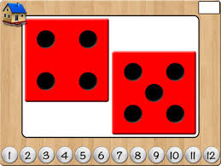  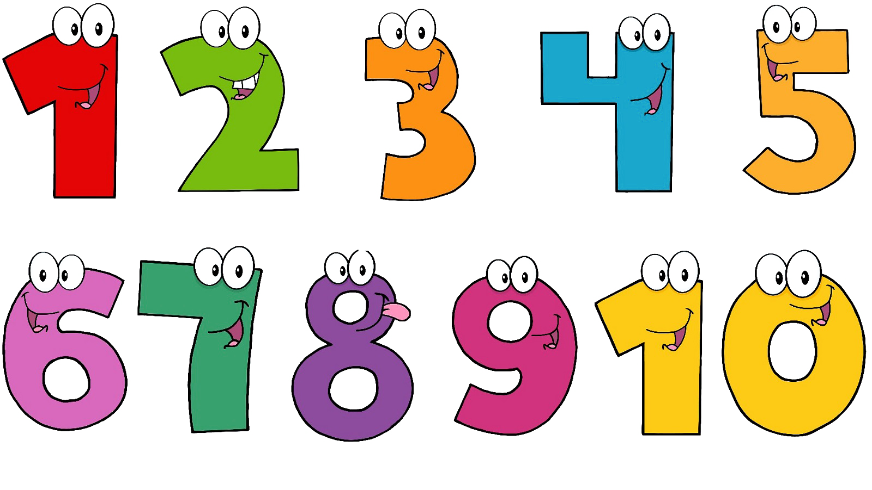 | Expressive arts and design  The children have taken an insterest in our musical instruments in the classsroom recently. We are going to be making our own musical instruments, using recycled materials.  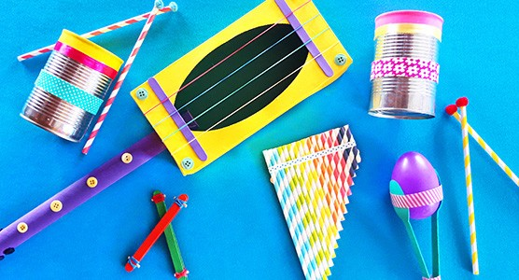  We will also be acting out the story of the gingerbread man and making our own puppets and props associated with the story. | Phonics  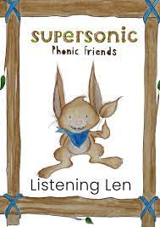  We will be embedding our phonological knowledge learnt so far. We will be doing lots of oral blending and playing fun phonics games. Remember to practise the oral blending home sheet.  