English  We will be looking at how to write instructions and then completing our own. | Maths  We will be learning about time. We are telling the time to the hour and half hour. | PE  Our focus in PE in this half term will be multi-skills Please ensure your child has a full, named PE kit including joggers as we will sometimes be outside.
Music  We will be exploring musical sounds and how they can be changed focussing on timbre, dynamics and pitch. | Week beginning 6.7.26  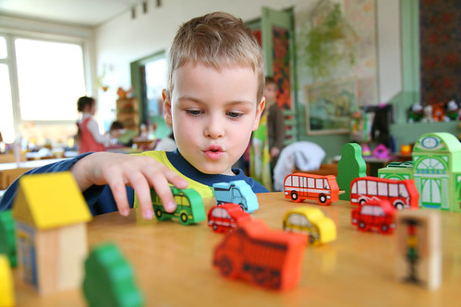 | Art  This half term our skill is sewing. We will be practicing threading a needle, and different types of stitches, towards making a final product.
Poetry  We will be looking at classic Poems from our “Poetry Basket”.  This half term our poems are “World” |  | Transition  We will be having our first transition morning this week where we will spend the morning in our new classes.
 | PSHE  Our topic this half term is all about diversity and communities. This week we will know that people can enjoy the same and different things. | History  This week we will be continuing our work on explorers by learning about Felicity Aston’s expedition across the Antarctic.
Phonics
We will be starting spelling rules in our phonics lessons this half term.

