Question of the Week –
What do aliens look like? What would it be like to live on a different planet? WB: 05.02.2024

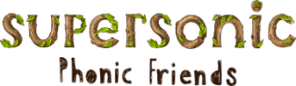  We are learning the spellings for the sounds oo, oo, ar and or beginning to use these in our writing.  We will also be focusing on our Tricky Tess words and our high frequency words. We will be developing our reading memory to help us read with speed. | In handwriting, we will be continuing to practise forming the letters we have been learning in Phonics  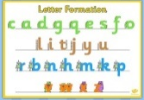  We will be recognising which letter family the letters come from and saying the ditties as we practice! | 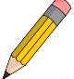  We will be writing about weird and wonderful aliens!  . 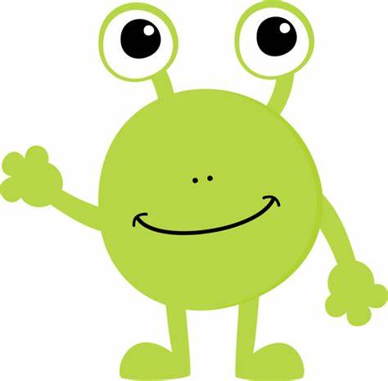 |  | Maths  In maths we will be consolidating our learning and thinking about how many objects are in a set.  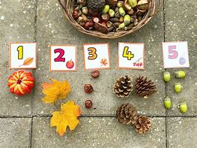  The last number in the count tells us how many things there are altogether.
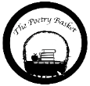  Climb Aboard the Spaceship!  Climb aboard the spaceship,  We're going to the moon.  Hurry and get ready,  We're going to blast off soon.  Put on your helmet,  And buckle up real tight.  Here comes the countdown,  Let's count with all our might.  10-9-8-7-6-5-4-3-2-1 Blast-off! | Our topic is  Explorer, Explorer –  Space  We will be reading  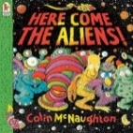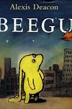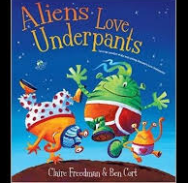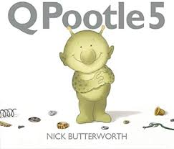  and looking at non-fiction books and information including Atlases and Encyclopaedias |  | Topic  In our topic sessions, we will thinking about what an alien might look like?  And what it might be like to live on a different planet?  We will be designing and then making our own playdough Aliens. |  | Parents Tips and reminders  Read! Read! Read!  Children will be allocated a specific day each week when they will change their reading books. Please continue to read at home every evening and sign to say you have heard your child read.  INSET Day  Friday 9th February 2024  Half Term  Monday 12th February 2024  to  Friday 16^{h} February 2024

