THE JOHN HAMPDEN SCHOOL WENDOVER – SCHOOL UNIFORM ORDER FORM – EARLY YEARS

CHILD’S NAME …………………………………………………………………………………………………………………………………………….

Item |  | Price | Quantity | Size | Colour  (Please state which colour you would  like) | Total cost
Navy Fleece (XS, S and age 3/4, 5/6, 7/8 with logo) | 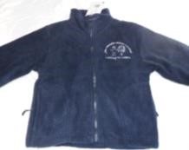 | £17.00 |  |  | Navy
Navy Sweatshirt with logo (24”, 26”, 28”, 30”,  32”) | 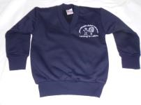 | £13.00 |  |  | Navy
Navy Sweatshirt Cardigan with logo (24”, 26”,  28”, 30”) | 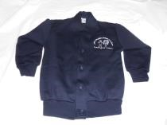 | £14.00 |  |  | Navy
White polo shirt with logo (age 3/4, 5/6, 7/8) | 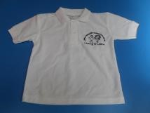 | £9.50 |  |  | White
Waterproof reading folder/book carrier with logo (navy, black, red, green, purple, royal blue, yellow)  PLEASE STATE COLOUR | 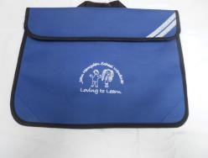 | £7.00
Woollen hat with logo (navy blue) – one size | 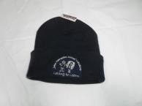 | £6.00 |  |  | Navy
Boys grey trousers (age 3/4)  (Phasing out – small supply of stock) | 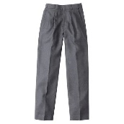 | £5.00 |  |  | Grey
** PLEASE TURN PAGE OVER |  |  |  |  | TOTAL | £

PLEASE MAKE PAYMENT ONLINE (BANK DETAILS ARE:- LLOYDS BANK, SORT CODE 30-90-38, ACCOUNT NUMBER 00943838, REFERENCE = CHILD’S NAME AND UNIFORM)
PLEASE STATE ON YOUR ORDER FORM WHEN YOU HAVE PAID ONLINE AND PLEASE ENSURE YOU STATE PAYMENT IS FOR UNIFORM AND PUT YOUR CHILD’S NAME IN THE REFERENCE FIELD ONLINE.
ORDER FORMS AND PAYMENT TO BE SUBMITTED TO US NO LATER THAN 19TH JUNE 2026 – THANK YOU
WHEN PAYMENT HAS BEEN RECEIVED YOU WILL BE NOTIFIED WHEN YOUR ORDER IS READY FOR COLLECTION – THANK YOU

