Question of the Week: What is the most important part of a plant? WB: 20.04.26
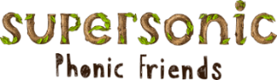  In Phonics we will be focusing on learning how to write cvcc words.  E.g. damp, tent  We will also be practising the following tricky words and high frequency words  there here said one  It’s children | In Handwriting,  We will be continuing to practise writing our letters. We will be focussing on:  h, b, p  We will be recognising which letter family the letters come from and saying the ditties as we practice! |   In Writing,  We will be writing dictated sentences and information books on flowers.  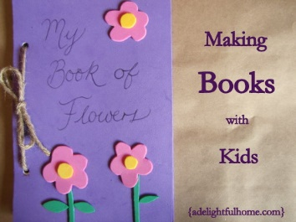 | Maths  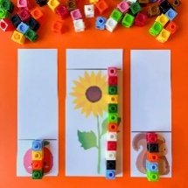  In Maths, we will be continuing our learning on length using the language of longest and shortest and measuring the lengths of different objects.
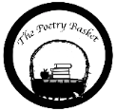  5 Little Peas  Five little peas in a pea pod pressed.  One grew. Two grew.  So did all the rest.  They grew, and they grew,  And they did not stop,  Until one day the pod went POP!  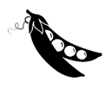 | Our topic is Nature Detectives – Growing  We will continue reading The Tiny Seed, Jasper’s Beanstalk and The Enormous Turnip.  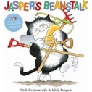  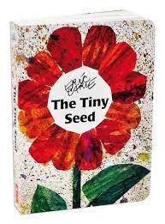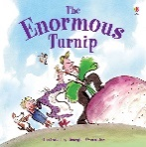  This week the children will be thinking about the lifecycle of a variety of plants. They will continue to identify and classify plants within our learning environment.  The children will revisit their previous learning and consider how the flower bulbs that they planted in the Autumn term have changed over time.  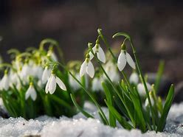  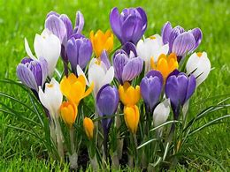  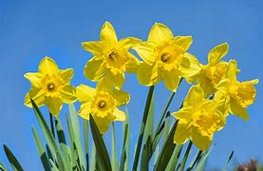 |  | Parents Notices  Coats & Sunhats  Please ensure children have a waterproof coat and a sunhat everyday. Please apply sun lotion if needed, preferably the all day one, - dependent on the forecast.    We are outside regardless of the weather.  Unless medically required, children should not bring sunglasses into school.

