PE  May Pole Dance Prep  Morris Dancer Moves  Mindful minutes  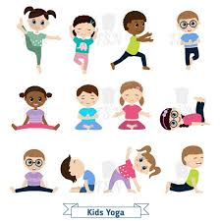 | ENGLISH  Traditional Tales: Children will be publishing their finished Traditional Tale Innovation.  Helicopter Stories using Tales Toolkit.  SPAG / HFW / TW / CEW    HANDWRITING  Getting ready for joining and number thirty six, 36  PHONICS  Daily Phonics Sessions.  READING  Daily Story Sessions & Learn a Poem.  Remember to bring in reading books and diaries every day. Please sign the diary when you have heard your child/ren read.  Guided Reading continuing our focus on fiction comprehension. | 23.3.26  We will continue to focus on our school Behaviour Expectations & Values.  We will be continuing to read:  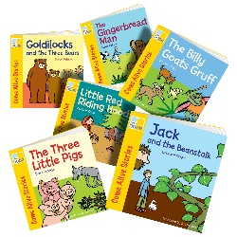  Traditional Tales | MATHS  The children will be looking at Multiplication.  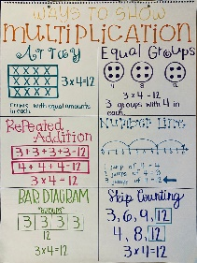 | MUSIC  A focus on singing expressively, playing tuned musical instruments, creative composing, responding to pitch changes and playing, creating and performing rhythmic patterns.  
ART / /COMPUTING  Printing ‘The Great Wave’ using foam boards, pens and water.  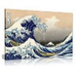 |  |  | HISTORY  The children are learning about pioneering nurse Edith Cavell.  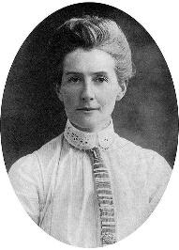  RE  The children are learning about the Easter Story & symbols.  
PSHE  Behaviour Expectations & Values  Reflection  Circle Time  Friendship   |  | Homework    Homework was issued on 12.3.26 on Book Reviews and will need to be returned on 24.3.26.  New homework will be issued after the Easter Holidays. | FINE & GROSS MOTOR  Funky Fingers  Crossing the mid-line.  Further developing of cutting skills.  