PE  Gymnastics  Mindful minutes  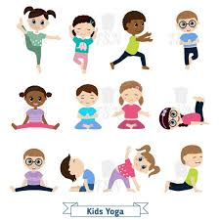 | ENGLISH  Traditional Tales: Children will look at the features of Traditional Tales. With a focus on Rapunzel  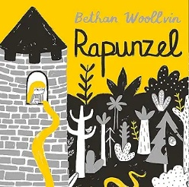  Helicopter Stories using Tales Toolkit.  SPAG / HFW / TW / CEW  HANDWRITING  Perfecting flicks ready to join and number handwriting.  PHONICS  Daily Phonics Sessions.  READING  Daily Story Sessions & Learn a Poem.  Remember to bring in reading books and diaries every day. Please sign the diary when you have heard your child/ren read.  Please continue to write and read the High Frequency and Tricky Words and Common Exception words too. | 23.2.26  Arts Week  We will continue to focus on our school Behaviour Expectations & Values.  We will be reading:  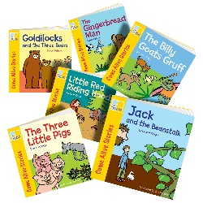  Traditional Tales | MATHS  Measuring & Estimating Length.  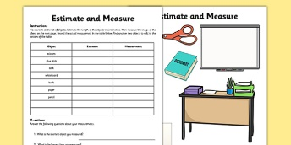 | MUSIC  A focus on singing expressively, playing tuned musical instruments, creative composing, responding to pitch changes and playing, creating and performing rhythmic patterns.  
COMPUTING  The children will be exploring the world of BlueBots and using their position and direction skills that they used in Math this term.   |  |  | ARTS WEEK  They will have a Perform Drama Workshop &  Mrs Mannering will be engaging children with musical activities.  The children will create a Dragons eye out of clay having shared the book Tell Me A Dragon.  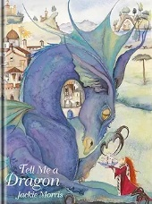  
PSHE  Behaviour Expectations & Values  Reflection  Circle Time   |  | Homework    New homework will be issued on 26.2.26 on Traditional Tales and will need to be returned on 10.3.26. | FINE & GROSS MOTOR  Funky Fingers  Crossing the mid-line.  Further developing of cutting skills.  