PE  Athletics    Mindful minutes.   | ENGLISH  Children will continue our poetry unit exploring poems from “Belonging Street” by Mandy Coe  Geography  The children will continue to build on their knowledge of Sri Lanka  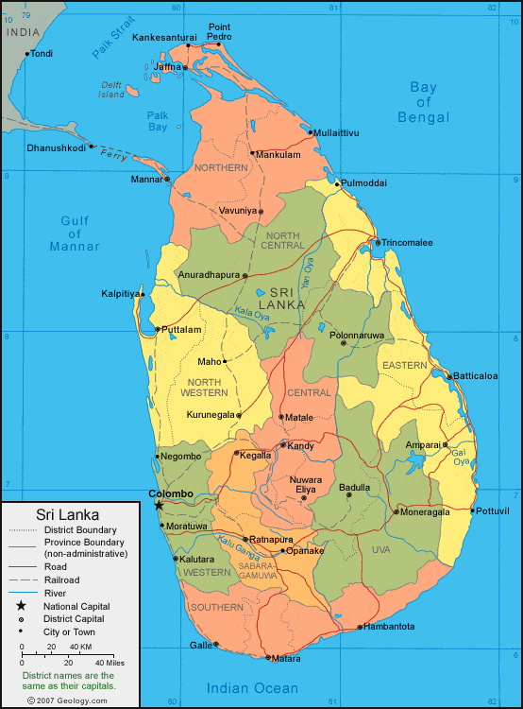  PHONICS  Daily Phonics Sessions.  Using an apostrophe to show posession | Year 2  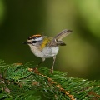  Firecrests  Weeks commencing  8.6.26  World week Sri Lanka   | MATHS  World Week Maths  The children will look at Statistics related to Sri Lanka, interpret the data, create pictograms and collect their own data.   | MUSIC  World Week Music: The children will experience some music and culture of Sri Lanka.  
 |  | Non-fiction, Stories & Poems & Atlases  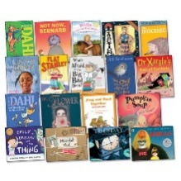 |  | HOMEWORK  Homework willl go out on 4.6.26 and needs to be returned on 16.6.26 linked to our learning on 3D Shapes.  Any writing should be done in pencil and pieces should use up to 2 pages. This homework will also require a ruler. Please continue to support your child/ren during the task and encourage them to take their time and think about the presentation of their work.
ART  The children will create a Sri Lankan Elephant  SCIENCE  We will explore the rainforest habitat in Sri Lanka. | ENGLISH  READING  Daily Story Sessions and learning a Poem.  Remember to bring in reading books and diaries every day. Please sign the diary when you have heard your child/ren read.  GUIDED READING  Continent of Europe, World Oceans Day & Amazing Antarctica | COMPUTING  The children will look at continents and oceans in the world and relate them to Sri Lanka. They will also research Sri Lanka and make notes.  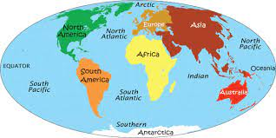 | PSHE  We will continue to focus on our School Behaviour Expectations & Values.  Reading stories from countries around the world. Taking part in discussions.     | FINE MOTOR  Cutting activities / Scissor skills.  Funky Fingers  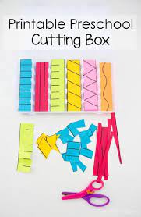  GROSS MOTOR  Windmill moves - ribbons & scarves.

