PE  May Pole Dance Prep  Mindful minutes  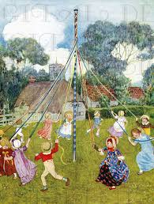 | ENGLISH  Children will be writing their own instructions on how to wash an animal of their choice.  We shall continue to use the book  How to Wash a Woolly Mammoth as inspiration, including our own version.  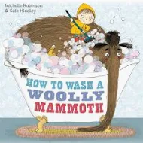  SPAG / HFW / TW / CEW. Reading comprehension  HANDWRITING  Joining patterns  PHONICS  Daily Phonics Sessions.  READING  Daily Story Sessions & Learn a Poem.  Remember to bring in reading books and diaries every day. Please sign the diary when you have heard your child/ren read.  Guided Reading: Comprehension Strategies. | 27.4.26  We will continue to focus on our school Behaviour Expectations & Values.  We will be reading:  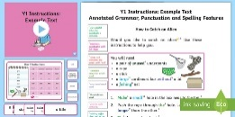  Instruction Texts & Reading Comprehensions | MATHS  Children will be looking at Fractions of a number and shape  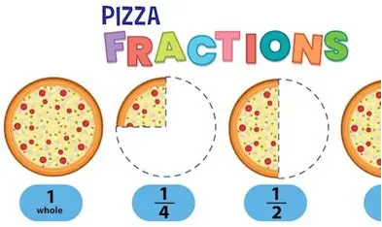 | MUSIC  A focus on singing expressively, playing tuned musical instruments, creative composing, responding to pitch changes and playing, creating and performing rhythmic patterns.  The children will also learn the May Day songs ‘Good Morning Ladies & Gentlemen’ and ‘Hey Ho! It’s our May Day Song!’  
ART – GEOGRAPHY  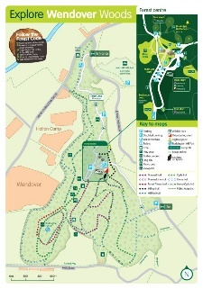  Children will create a planned perspective of Wendover Woods. They will look at previous maps and apply the knowledge of compass points and keys.  COMPUTING  The children will continue to learn all about spreadsheets. |  |  | SCIENCE  The children will be learning about Plants. They will be focusing on seed dispersal.  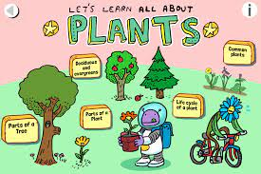  Performance  Children will dance around the May Pole during our May Day celebrations.  The chosen Morris People will dance a traditional dance.
PSHE  Behaviour Expectations & Values  Reflection  Circle Time  Family   |  | Homework    New homework will be based on instruction writing and will be issued on 30/4/26. It needs to be returned on 12.5.26  If there is an issue with completing it on time, do speak to your child’s teacher. | FINE & GROSS MOTOR  Funky Fingers  Crossing the mid-line.  Further developing of cutting skills.  

