WB: 20.10.25 | Value: Reflecting on all our School Values | Behaviour Expectation: Reflecting on all our Behaviour Expectations
`
Growth Mindset Week

Growth Mindset Week  Whole School Aims    - Help children understand that brains grow stronger when we learn.  - Teach the power of “yet” (“I can’t do this… yet!”).  - Celebrate mistakes as part of learning Encourage persistence, resilience, and effort. | Core Books    Giraffes Can’t Dance  Believing in yourself and trying things even if you think you can’t do them.  - It’s ok if I get it wrong.  - I’m getting better.  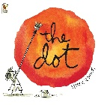  The Dot  I cant do it…YET. Believe in yourself.  - I can’t do this…yet.  - This is hard but I can do it. | The language we will be engouraging the children to use when they find something tricky:  - It’s ok if I get it wrong.  - I’m getting better.  - I can’t do this…yet.  - This is hard but I can do it. | Poetry Basket  We will be practising all the poems we have learned so far.  
We will revisit Austin’s Butterfly and make our work even better with another draft of our drawing.
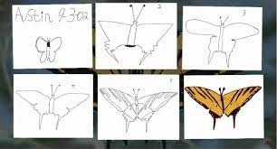
https://www.youtube.com/watch?v=E_6PskE3zfQ
Phonics  We will continue to hear syllables in words. We will be learning the spellings for the sounds: ll, ff, ss  We will be learning to read the tricky words of and into and the high frequency word off. Please see Parents Phonics Newsletter for further details. | In Maths we will continue to practise our subitising to 5 and we will be looking for patterns in our environment. For example, on leaves, brickwork.     |  | Please share Library Book Club book  
The children will be independently printing using all of the printing tools they have learned so far – including forks, dabbers, cotton wool buds, sponges and fingers!

