Question of the Week: Do all minibeasts stay the same?
WB: 22.04.24
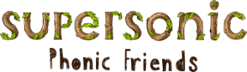  In Phonics we will be learning the new spellings for the sounds  ai, ee, igh and oa.  We will continue to practise reading and writing the Basic 3 tricky Tess words and high frequency words. | In Handwriting,  we will be forming the zig zag letters  f and s.  We will be recognising which letter family the letters come from and saying the ditties as we practice! | In Writing,  we will be learning to write facts about our class mini beasts  and then writing facts about other mini beasts we know about  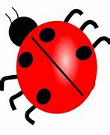  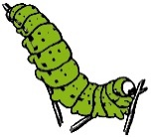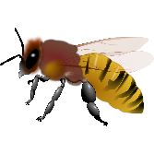 | Maths  In Maths we will be learning about doubling. The children will practise recalling doubles to 6.  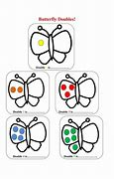
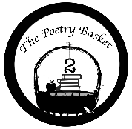  Creepy Crawlies  Creepy crawly up my arm,  A spotty little bug.  Then it crawled up to my neck,  I gave a little shrug.  Then it climbed a little more,  And settled on my nose.  So I gave a mighty snore,  And it scuttled to my toes.  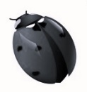 | Our topic is Nature Detectives – Minibeasts  We will be reading  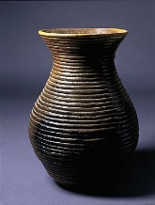  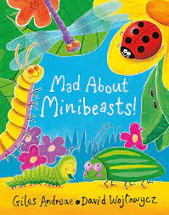  In Art we will be learning about the famous artist Louise Goodman. In particular, we will be focusing on her clay coil pots. Using moulding and shaping techniques we will be aiming to create our own master pieces.  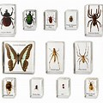  We will be exploring and sorting a variety of mini beasts by their different features. We will also be going on a mini beast hunt around the garden. |  | Parents Hints and Tips  Special Requests  We are sorely in need of materials for junk modelling. Please could you bring in any recyclables to help us restock. In particular, kitchen rolls and cereal boxes would be greatly appreciated.  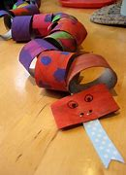  Coats & Sunhat  Please ensure children have a waterproof coat and a sunhat everyday We are outside regardless of the weather.

