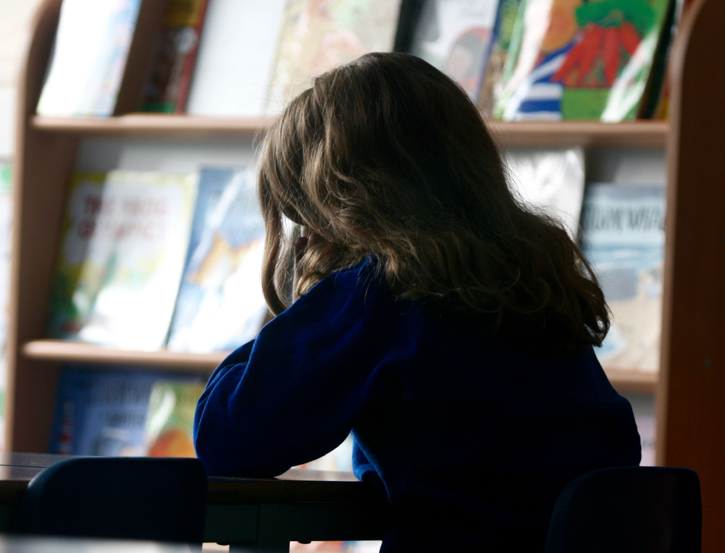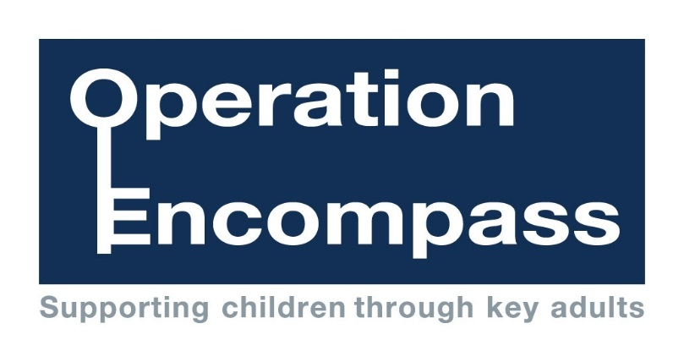

We are an Operation Encompass school.

Operation Encompass is the early reporting on to schools that a child

or young person has been exposed to domestic abuse

For further information, please come in and see us.

Photo posed by model

Supporting Children Exposed to Domestic Abuse

Photo posed by models