PE  Multi-Skills  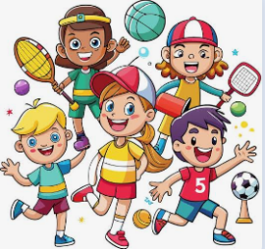  Playground Equipment Games  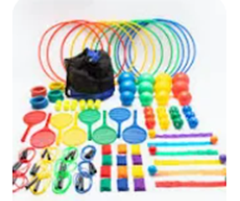  Focus: Idependent play | ENGLISH  Luna Loves to Dance  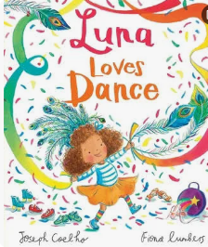  This week we will be introducing our new narrative, Luna Loves to dance.  HANDWRITING  Practising the letter formation families and 14 fourteen  PHONICS  Daily Choose to Use Phonics Sessions  READING  Daily Story Sessions & Learn a Poem.  Remember to bring in reading books and diaries every day. Please sign the diary when you have heard your child/ren read. | 05.10.26  Our question of the week is:  How does the food we eat help our bodies?  Our value this week is:  Independence  Our Behaviour Focus this week is:  ‘Do be Honest’  Poem we are reading:  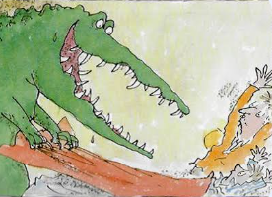  The Crocodile Roald Dahl | MATHS  Number  We will be introducing the part-part-whole model to further imbed our understanding of place value.  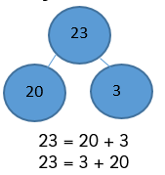 | MUSIC    To copy rhythmic patterns.  To create a rhythmic pattern based upon spoken words.  To play rhythms to a steady pulse.
COMPUTING
Coding Continued
Understand what algorithms are.

Create and debug simple programs.

ART  Sketching and Mark Making  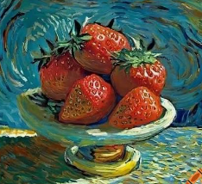  We will continue to recreate a picture of strawberries using our mark making skills.  We will also look at the differences in various H and B pencils. | PSHE  What does it mean to be Independent?  Do be honest  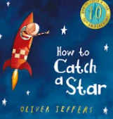   | Science  This week we will be learning about the importance of healthy eating and good hygiene.  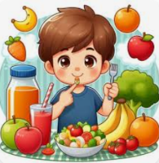   |   Independence  Can your children complete the ‘Independence’ challenge and as a family, talk about this value and the importance of it.  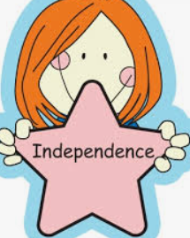 | Geography  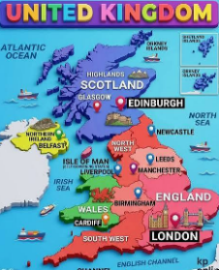  We will be learning about the four countries that make up the U.K.  This week we will be learning about Ireland including capital city, national flower, highest mountain and longest river.

