PE  Gymnastics  Mindful minutes  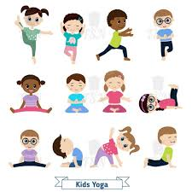 | ENGLISH  Writing Poetry  HANDWRITING  Number Handwriting and words containing Curly Cal, Lens Ladder or Zig Zag Letters  PHONICS  Daily Phonics Sessions  READING  Daily Story Sessions including Helicopter Stories, Tales Toolkit Stories and Talk for Writing & Learning Poems.  Remember to bring in reading books and diaries every day. Please sign the diary when you have heard your child/ren read. | 13.10.25  Our value this week is:  Reflection  We will be reading  I wonder poem by  Jeannie Kirby | MATHS  Number  Revision and consolidation of knowledge and recognition of number, place value and counting in 2s, 5s and 10s.  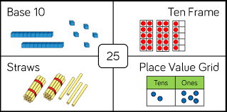 | MUSIC  Songs & rhymes  
 |  |  | SCIENCE  Children will be looking at Animals including Humans and their Basics Needs  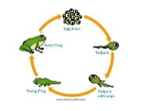 | COMPUTING    E-safety & Laptops
ART  Mark Making  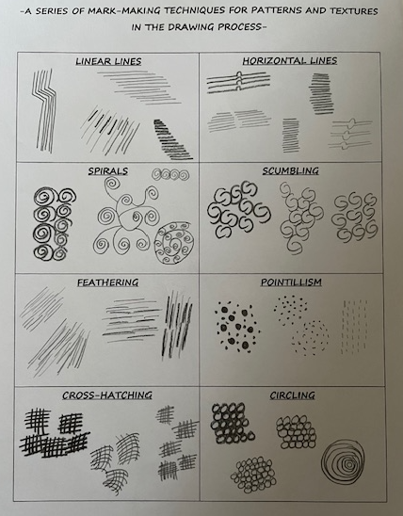 | PSHE    Books linked to Reflection  The Invisible String | SCHOOL VALUE ACTIVITIES AT HOME  Perhaps your child/ren could do the following at home to model Reflection:  Writing a diary  Show gratitude  A Positive Daily Thought  Say it, write it, draw it  Drawing / Painting of themselves, add post its or write around the outside positive thoughts from you / others including family and friends  Reflect upon an important event ‘this week’  Create a paper chain of reflection | Homework    New homework was issued on 9/10/25 and needs to be returned by 21/10/25.  They need to find and write and decorate their own autumn poem. | FINE & GROSS MOTOR  Funky Fingers:  Cutting Skills  Crossing the mid-line  

