Autumn 1 Week 4
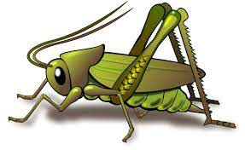
Value of the week: Good Manners
Activities based on the interests of the children….
Our story  This week our core text is The Elephant and the Bad Baby by Elifrida Vivpont.  We will also be reading familiar stories from our classroom.  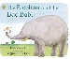 | Poetry basket  We will be listening to stories, rhymes and fairy tales.  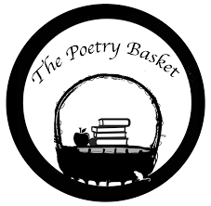  We will also be learning our second poem from Poetry Basket. This is a special rhyme and movement activity we do during our morning sessions. It is great fun and features a range of seasonal and classic poems. See if your child can recite our first poem to you. It is called Chop Chop. We would love you to share these poems with your child each week.  Wise Old Owl  A wise old owl sat in an oak,  The more he heard, the less he spoke.  The less he spoke, the more he heard.  Why aren’t we all like that wise old bird? | Phonics  We will be beginning to use our listening ears by going on a sound walk inside and outside the classroom, to see what we can hear. Also, in circle time, we will be playing other Communication and language games.  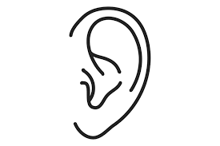
Maths  We will be doing lots of number rhymes and singing this week. We will be singing our Number Rhyme is 10 in the Bed  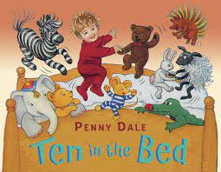  We will be subitising groups of objects (0-3). We will practice trying to say how many things we can see without counting.   | Our value of the week  Our value this week is: Good Manners  Our behaviour expectation this week is: Do be polite and do be gentle.  We will be doing lots of learning based around being polite and using good manners.   | Mark making  We are developing our gross motor skills with our ‘Squiggle while you Wiggle’ dance. We will be practising our mark making whilst we play.  We will also be continuing to make different marks outside using large up/down movements whilst using the water brushes, chalks, sand, and in the air with noodles and scarves.  We will be practising the pre writing pattern I.

