Question of the Week: What is the most important part of a plant? WB: 28.04.25
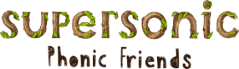  In Phonics we will be focusing on learning how to write cvcc words.  We will also be practising the following tricky words and high frequency words  there here said one  It’s children | In Handwriting,  we will be continuing to practise writing our letters. We will be focussing on:  e, f, s  We will be recognising which letter family the letters come from and saying the ditties as we practice! |   In Writing,  we will be writing dictated sentences and information books on flowers.  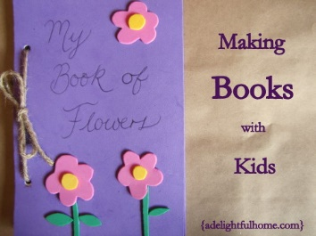 | Maths  In Maths, we will be continuing our learning on length using the language of longest and shortest and measuring the lengths of different objects. We will also be subitising to 6 using structured and unstructured arrangements.  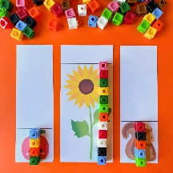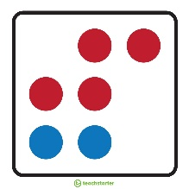
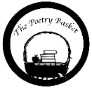  A Little Seed  A little seed for me to sow,  A little soil for it to grow.  A little hole, a little pat,  A little wish, and that is that.  A little sun, a little shower,  A little wait, and then a flower.  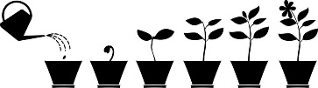 | Our topic is Nature Detectives – Growing  We will be reading The Tiny Seed, Jasper’s Beanstalk and The Enormous Turnip.  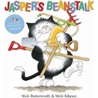  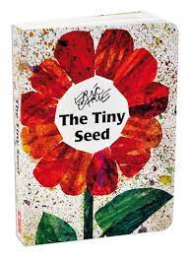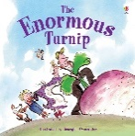  This week the children will be thinking about the lifecycle of a variety of plants. They will continue to identify and classify plants within our learning environment.  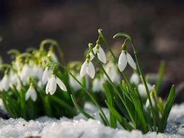  The children will revisit their previous learning and consider how the flower bulbs that they planted in the Autumn term have changed over time.  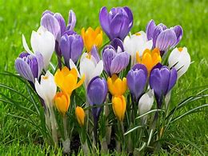  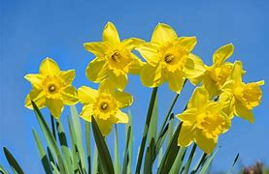 |  | Parents Notices  Reminder  BANK HOLIDAY  MONDAY 5TH MAY 2025  Coats & Sunhats  Please ensure children have a waterproof coat and a sunhat everyday. Please apply sun lotion if needed, preferably the all day one, - dependent on the forecast.    We are outside regardless of the weather.

