PE  Gymnastics  Mindful minutes  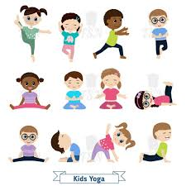 | ENGLISH  Writing Character Descriptions  HANDWRITING  Number Handwriting and words containing Curly Cal, Lens Ladder or Zig Zag Letters  PHONICS  Daily Phonics Sessions  READING  Daily Story Sessions including Helicopter Stories, Tales Toolkit Stories and Talk for Writing & Learning Poems.  Remember to bring in reading books and diaries every day. Please sign the diary when you have heard your child/ren read. | 29.9.25  Our value this week is:  Respect  We will be reading  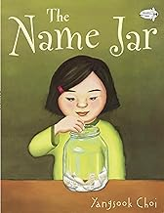  Yangsook Choi | MATHS  Number  With a focus on Place Value  Place value Tens & Ones: showing numbers using abstract, pictorial and concrete representations.  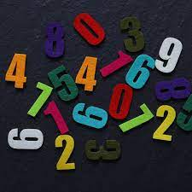 | MUSIC  Songs & rhymes  
 |  |  | SCIENCE  Children will be looking at Animals including Humans and their Basics Needs  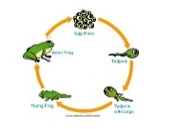 | COMPUTING    E-safety & Laptops
ART  Mark Making  FJHS Christmas Cards  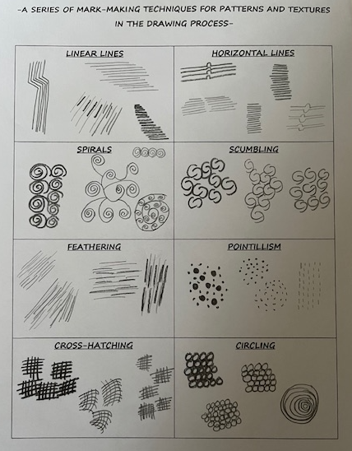 | PSHE    Books linked to Respect  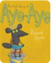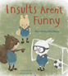  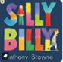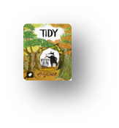 | SCHOOL VALUE ACTIVITIES AT HOME  Perhaps your child/ren could do the following at home to model Good Respect:  Help tidying up at home  Take turns in games  Litter picking in your local area  Compliment somebody in your family or a friend  Practice ‘active listening’ – not interrupting | GEOGRAPHY  Children will continue to learn about UK: England, Scotland, Wales, Northern Ireland.   | FINE & GROSS MOTOR  Funky Fingers:  Cutting Skills  Crossing the mid-line  
Homework

Children need to neatly decorate their homework books.
Homework went out on 25/9/25 and needs to be returned by 7/10/25.

