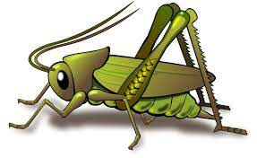
Summer 2 Week 6
Question of the Week: How have you changed?
Activities based on the interests of the children….
NELI  This week’s Neli – N book is called ‘Stardust’ by Jeanne Willis  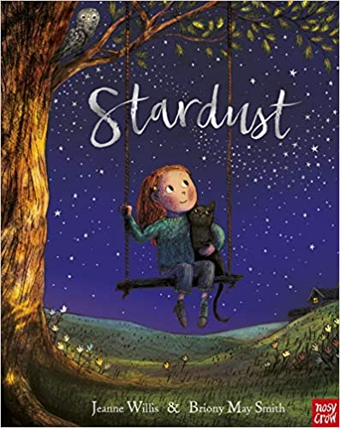  A story about aiming for the stars and reaching goals.  This week we will be reflecting on all that we have achieved in Crickets this year. | Poetry basket  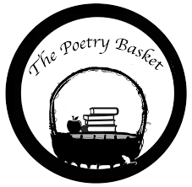  Our Poetry Basket Poem this week is;  If I were so very small  If I were so very small,  I’d walk amongst the trees  And stretch to reach the top most leaf,  As easy as you please,  And if I were so very small,  I’d hide myself away,  And creep into a buttercup,  To spend a Summer’s day. | Our rhymes  Our Number rhyme this week is 5 Green Bottles  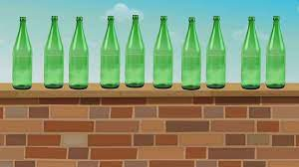  And this week’s Nursery rhyme is ‘Sleeping Bunnies’.  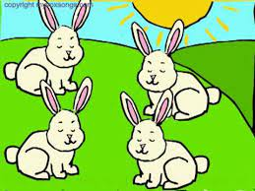
Maths  We will be consolidating all our number and maths skills this half term..  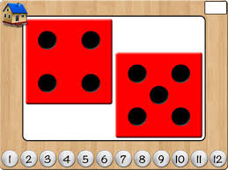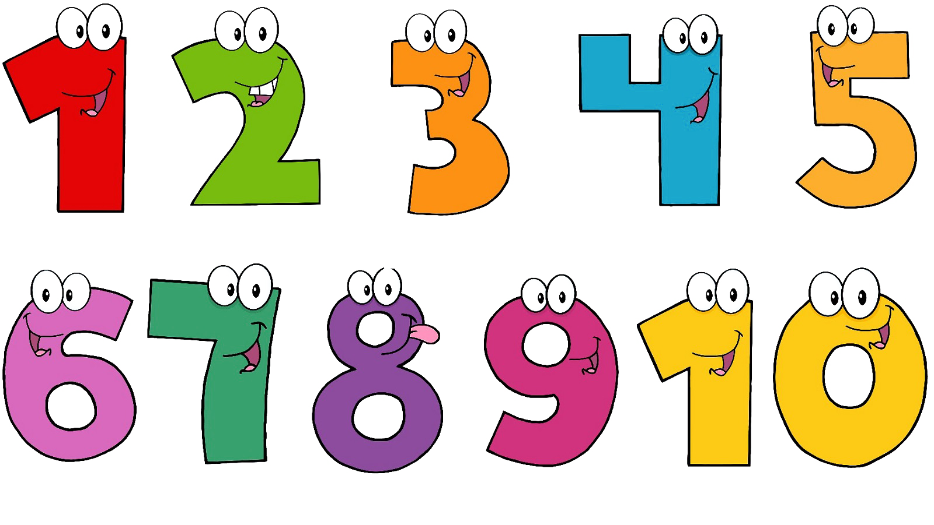 | Expressive arts and design  We will be using different materials to make our own shooting stars. We will also be making some stars out of salt dough and then painting them.  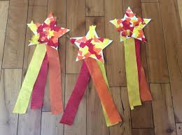 | Phonics  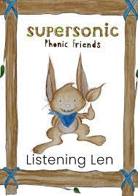  We will be embedding our phonological knowledge learnt so far. We will be doing lots of oral blending and playing fun phonics games. Remember to practise the oral blending home sheet.  