PE  Athletics  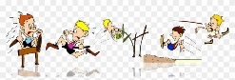  Yoga – breathing, balance & control as well as activities to improve core strength.  Mindful minutes.  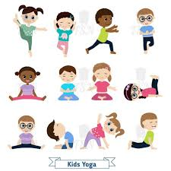 | ENGLISH  The children will be reading poems from the poetry book ‘Belonging Street’ and creating poems of their own.  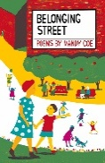  Geography  The children will write down questions about what they would like to find out about Ecuador. They will learn about the national flag and they will learn about the location of the country in the world as well as the geography within Ecuador.  They will also learn about the continents and oceans in the world.  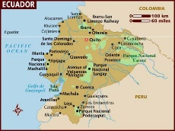 | Year 2  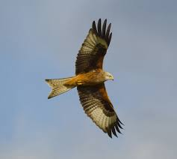  Week commencing  1.6.26  World week  Ecuador: Red Kites  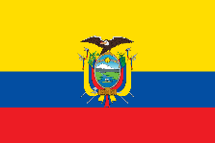 | MATHS  World Week Maths:  The children will look at the geography of Ecuador and use positional & directional language, including compass directions.  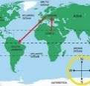  The class will also explore mass - packing a suitcase for a holiday to Ecuador.  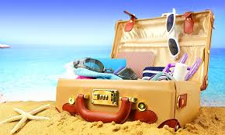  They will explore measurement (height, weight, population & life expectancy) through Top Trumps looking at data about Ecuador animals.  The class will also explore money and investigate the cost of different items and compare these to prices in the UK. | MUSIC  Songs & rhymes about Ecuador.  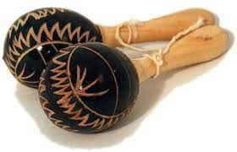  Learning and singing a song in Spanish.
HOMEWORK
Homework will go out on 4.6.26 and needs to be returned on 18.6.26 The Homework is linked to transition. They will be writing a letter about themselves for their new teacher.

Any writing should be done in pencil. Please support your child/ren during the task and encourage them to take their time and think about the presentation of their work.
Non-fiction, stories & poems & atlases
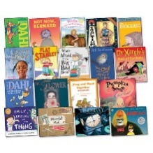
Art  The children will create their own Ecuadorian wall hangings.  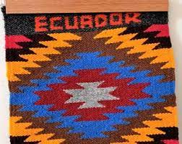  Clay work to create Inca store houses.  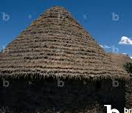 | PHONICS  Daily Phonics Sessions.  High Frequency & Tricky words plus Year 2 Common Exception words. Phonics games - blending to read & segmenting to spell using sounds taught.  HANDWRITING  Writing numbers as words in Spanish plus we will continue to look at letter formation and joins. Also, they will focus on word number handwriting.  READING  Daily story sessions and learning a poem.  Remember to bring in reading books and diaries every day. Please sign the diary when you have heard your child/ren read.  GUIDED READING: Continents, Oceans & Antarctica. | COMPUTING  The children will look at continents and oceans in the world and relate them to Ecuador. They will also research Ecuador and make notes.  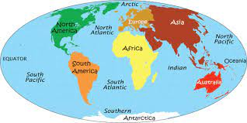 | PSHE  Reading stories from countries around the world. Taking part in discussions.  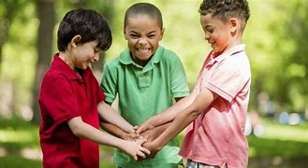  Transition – coping with change.  GUIDED READING  Continents, Oceans & Antarctica | FINE MOTOR  Cutting activities.  Funky Fingers  Scissor skills.  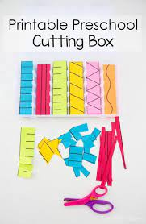  GROSS MOTOR  Windmill moves - ribbons & scarves.

