  - Question Of the Week: How do colours make us feel? WB: 20.11.23
Story  We will be reading the story  ‘The Crayons that Quit’ By Oliver Jeffers.  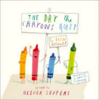 | Understanding the World  We will be continuing to learn about light and dark recognising there are different light sources. Within our environments. We will also explore a dark den within our classroom. |  |  | Maths  We will be going on a colour hunt around the classroom and garden.  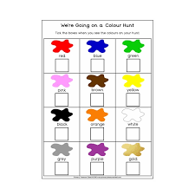
Creative  We will be choosing different colours and media to create pictures. | Poetry Basket  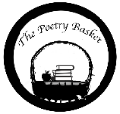  We will be recapping all poems we have learnt so far. |  |  | Handwriting  We will be continuing to practice writing the correct letter formation for ck, e, u, r,  We will be also be practicing writing tricky words and short captions and sentences e.g  the hen, a rat, it is a dog….
Curiosity Question of the Week
What is your favourite colour and why?
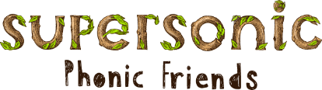  In Supersonic Phonics we will be continuing to revisit and revise the spellings for the sounds ck, e, u, r.  We will continue to learn ‘Tricky Tess’ words  go, no  and practicing our High Frequency Words  up, mum, put, get. |  | We will be continuing to think about our Christmas play learn the songs for our Christmas play  ‘Wriggly Nativity’  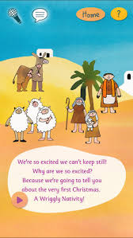 | Parents Tips and Reminders  Please ensure children bring their Reading Folders into school every day. These will then be changed on a Friday.  Please return all PE bags to school too. Thank you.  Friday 24th November - MUFTI DAY - Children can come into school in their own clothes.  Saturday 25th November – Christmas Fair

