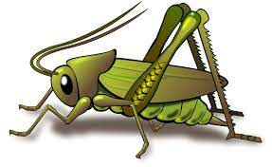
Safety Week People Who Help Us Autumn 2 Week 1
Value of the Week: Be the Best that you can be
Activities based on the interests of the children….
This week we will be embedding our school Values and Behaviour Expectations from last half term.  It is Safety week and we will be learning about people who help us and ways in which we can keep ourselves safe.  We will have visits from a Police Officer and Road Safety Officer.  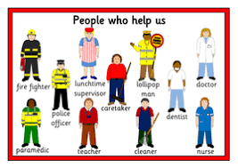 | We will be listening to stories, rhymes and fairy tales.    We are starting to learn our Christmas Poems and songs ready to show you.   | This week is Safety week and we will be thinking about People Who Help Us. We will be learning through the story books that we share and role play.  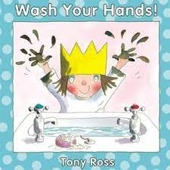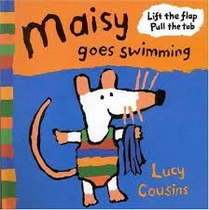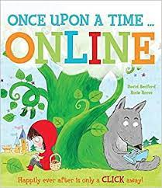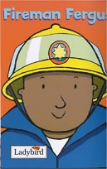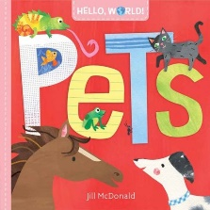  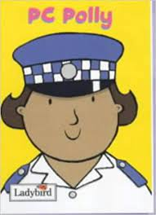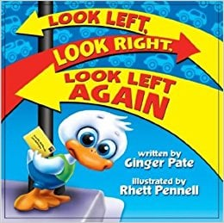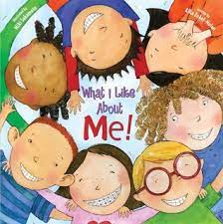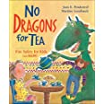  We will be singing the Nursery Rhyme ‘Old MacDonald Had a Farm’
This week our Number Rhyme is  1 Potato, 2 potato..  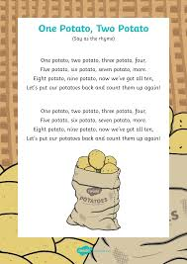  We will continue to subitise groups of objects (0-3).  We will be focusing on 1, squares, show me fingers and counting using the number stick. | We will be using different media and materials to create fireworks artwork.   | We are introducing the Supersonic Phonics this week. Firm foundations develops general sound discrimination. Initially the children will tune into environmental sounds, instrumental sounds and body percussion with the help of the playful character Listening Len who is a supersonic phonic friend.  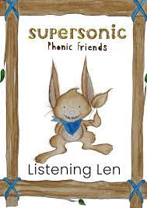  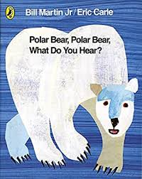  This week the focus will be on Environmental sounds. We will be identifying, recollecting and talking about different sounds.  Ideas for activities at home: Identify and talk about animal sounds. moo, ribbit, hiss, quack, neigh, tweet, buzz, twit twoo.  We will be reading the story Polar Bear , Polar Bear, What do you hear?

