PE    Dancing    Mindful minutes | ENGLISH  Children will be reading the story The Lost Homework. In preparation for writing their own story about the experiences of others.  .  The Lost Homework  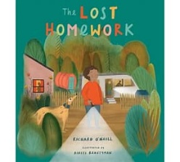  SPAG / HFW / TW / CEW. Reading comprehension  HANDWRITING  DiagnolJoining patterns  PHONICS  Daily Phonics Sessions.  READING  Daily Story Sessions & Learn a Poem.  Remember to bring in reading books and diaries every day. Please sign the diary when you have heard your child/ren read.  Guided Reading: Comprehension Strategies. | 4.5.26  We will continue to focus on our school Behaviour Expectations & Values.  We will be reading:  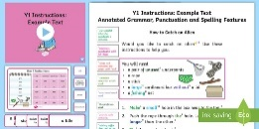  Instruction Texts & Reading Comprehensions | MATHS  Time  Children will be using the clocks they made in PPA to show and tell time including o’clock, half – past, quarter to and quarter past. They will also explore 5-minute increments.  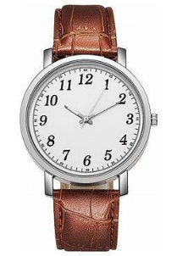 | MUSIC  To use movement to respond to pitch and recognise a notes relationship to another using higher & lower. To recognise high, mid and low-pitched sounds and use graphic notation to represent pitch. To pitch match simple phrases and explore vocal timbre.  To play ascending and descending melodies on tuned percussion. To compose & notate a short composition using graphic notation and recognise and describe changes in pitch  
ART – SEWING  Children will use various stitches to create a tasselled bookmark.  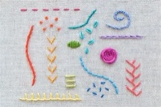  COMPUTING  The children will use data to create a table and bock graph. |  |  | SCIENCE  The children will be learning about Plants. They will be focusing on pollination.  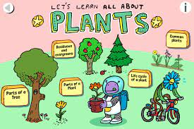
PSHE  Behaviour Expectations & Values  Reflection  Circle Time  Family   |  | Homework    New homework will be based on instruction writing and will be issued on 30/4/26. It needs to be returned on 12.5.26  If there is an issue with completing it on time, do speak to your child’s teacher. | FINE & GROSS MOTOR  Funky Fingers  Crossing the mid-line.  Further developing of cutting skills.  

