PE  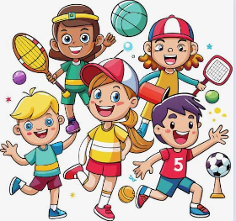  Multi-Skills | ENGLISH  Starting our narrative topic  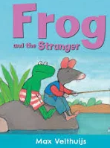  This week we will be writing simple sentences, using conjunctions and learning about statement sentences.  HANDWRITING  Capital letters and lowercase letters:  Aa, Bb,Cc and 11 eleven  PHONICS  Daily Choose to Use Phonics Sessions  READING  Daily Story Sessions & Learn a Poem.  Remember to bring in reading books and diaries every day. Please sign the diary when you have heard your child/ren read. | 14.09.26  Our question of the week is:  What is my story?  Our value this week is:  Collaboration  Our Behaviour Focus this week is:  ‘Do be kind and helpful’  Poem we are learning:  We are all different!  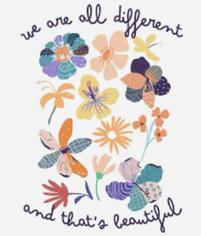 | MATHS  Number  We will be skip counting in steps of ten backwards and forwards, recognising place value & representing numbers in a variety of ways. We will understand and use the terms -10 more and 10 less, alongside varied representations, including money.  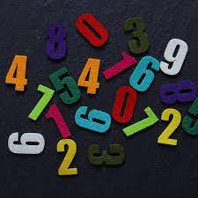 | MUSIC  Maintaining a steady pulse, copying pulse action sequences and Harvest songs  
COMPUTING

Familiarisation with a laptop, logging on and off and revisiting Purple Mash games.

ART/CRAFT  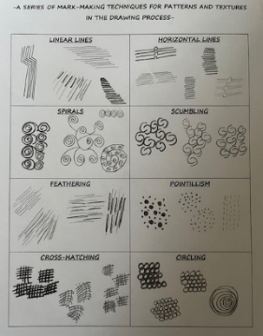  Mark Making  We will be revisiting the mark making techniques taught in year 1 | PSHE  What does collaboration mean?  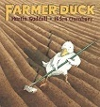  Do be kind and helpful  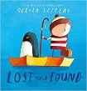   | Science  We will be thinking about the Basic Needs of Humans and what they need to stay alive.       | 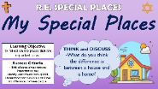  RE  Important Places of Worship  Talking about how religions have their own special places. | History  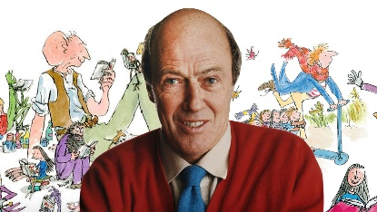  We will be learning about the author Roald Dahl and thinking about significant events in his life. We will order the events and create a timeline.

Collaboration
Work together to complete a puzzle or task. Discuss the importance of collaboration ready for a class discussion.

