English  This week we are reading The Squirrels that Squabbled by Rachel Bright and linking this to our value of the week. We will be writing a list poem. | Maths  Next week in Maths we are looking at 1 more and 1 less within 10. We will be looking at the composition of numbers within 10, we will be making the numbers in different ways. | PE  Our focus in PE in thishalf term will be multi-skills Please ensure your child has a full, named PE kit including joggers.
Music  We will be rehearsing our Harvest Festival Songs. We will be thinking about using our voices to create an effect. | Week beginning 15.09.25  Incredible Me!  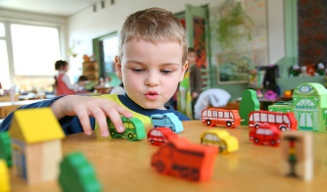 | Science  Animals and Humans  We will be thinking about the amazing human body. We will be looking at naming different parts of the body and making labelling the body.
Poetry  We will be looking at classic Poems from our “Poetry Basket”.  This half term our poems are “All About Me” |  | Art  This half term we are going to be looking at sketching and mark making in Art and using H and B pencils to create different effects.
 | PSHE  This half term we are focusing on looking at our school values and what they mean. This week we are going to be looking at collaboration and why this is important and how we can show collaboration. | Geography  Next week we will be reading ‘Martha Maps it Out’ and thinking about our local geography and where we live.
Phonics
We will be recapping and reviewing Basics 4 and reading CVCC words.

