  - Question Of the Week: How do colours make us feel? WB: 13.11.23
Story  We will be reading the story  ‘The Colour Monster’  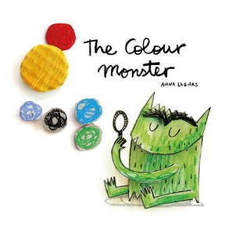 |  | Feelings  We will be creating our own ‘feelings picture’ to express ourselves using a choice of media of their choice eg collage, paint. This links to our Zones of Regulations and how colours make us feel.  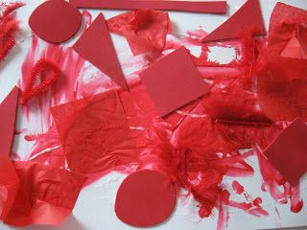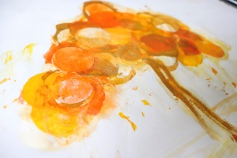 |  | Light and Dark  We will be exploring how light is essential for seeing things. We will be introducing the words light, dark, bright, black, day and night.  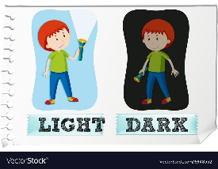
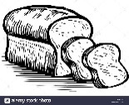    Sliced Bread  Slice, slice, the bread looks nice.  Spread, spread, butter on the bread.  On the top put jam so sweet,  Now it's good enough to eat. | Handwriting  We will be continuing to practice writing the correct letter formation for g, o, c, k.  We will be also be practicing writing tricky words and short captions and sentences e.g  A cat, the dog sat, it is a cat….  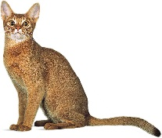
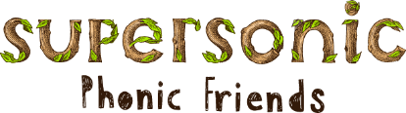  In Supersonic Phonics we will be continuing to learn our tricky words. This week we will be practising  On, can, got, no |  |  | Parents Tips and Reminders  Please ensure children bring their Reading Folders are brought into school every day. These will be updated on a Friday.  Friday 17th November – Muffti Day for Children In Need  Children can come into school in their own clothes in return for filled Jam Jars and tombola donations

