PE  Gymnastics  Mindful minutes  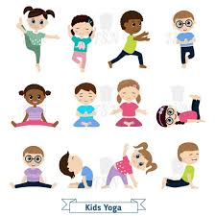 | ENGLISH  Traditional Tales:  Exploration  Helicopter Stories using Tales Toolkit.  SPAG / HFW / TW / CEW  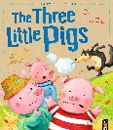  HANDWRITING  Joining patterns and number thirty two 32  PHONICS  Daily Phonics Sessions.  READING  Daily Story Sessions & Learn a Poem.  Remember to bring in reading books, diaries every day. Please sign the diary when you have heard your child/ren read.  Guided Reading  SPAG  Opportunities to practise our knowledge and understanding of Spelling Punctuation and Grammar. | 2.3.26  World Book Week  We will continue to focus on our school Behaviour Expectations & Values.  We will be reading:  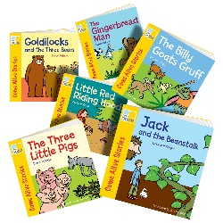  Traditional Tales | MATHS  Money – finding change, identifying coins and notes, adding coins, making amounts  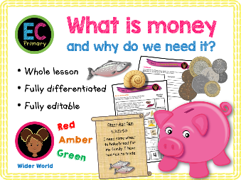 | MUSIC  A focus on singing expressively, playing tuned musical instruments, creative composing, responding to pitch changes and playing, creating and performing rhythmic patterns.  
ART / /COMPUTING  Finishing Dragon Eye Art  Jack and the Beanstalk  Blue bots |  |  | WORLD BOOK WEEK  Performance Poetry  Teacher Story Swap  Live Author Event  Masked Reader  Book Swap  Fiction / Non-Fiction Focus  I wonder…  Dress Up Day Friday 6th March    Geography  Design a planned perspective map which incorporates keys, compass points and locations to help Red Riding Hood get to Gramdma’s house.
DT
The children will work on some paper folding techniques and plan for their puppet design.
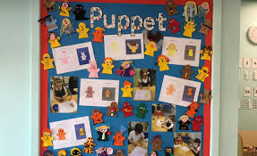
PSHE  Behaviour Expectations & Values  Reflection  Circle Time  Money   |  | Homework    New homework was issued on 26.2.26 on Traditional Tales and will need to be returned on 10.3.26. | FINE & GROSS MOTOR  Funky Fingers  Crossing the mid-line.  Further developing of cutting skills.  