WB: 12.05.25 Question of the Week: Do all minibeasts stay the same?
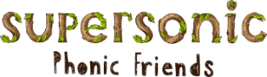  In Phonics we will be focusing on learning how to read and write CVCC words as well as learning Basic 4 tricky and high frequency words | In Handwriting, we will be revising the Lens Ladder letters  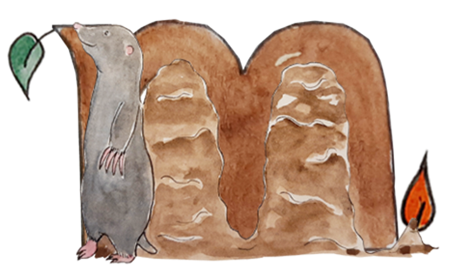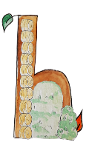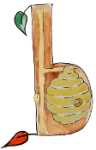  We will be recognising which letter family the letters come from and saying the ditties as we practice! |   In Writing,  we are creating our own story wheels based on food eaten by either a ladybird, honeybee or caterpillar as well as our own chosen animal. | Maths  In Maths, the children will be exploring the composition of numbers 6 and 7 using the ‘5 and a bit’ model. We will be embedding our learning on using a tally chart when we go on our minibeast hunt and also will be exploring symmetry too.  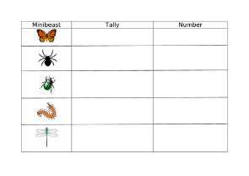
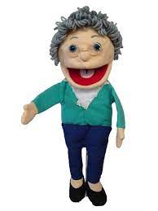  hungry, famished, ravenous  well fed full bursting  Curious Conversations  Would you dare to squash a scary  spider?  (But what if it was the only one in the world?) | Our topic is Nature Detectives – Life Cycles  This week we will be exploring the lifecycle related to our class animal – Ladybirds, Honeybee, Caterpillar.  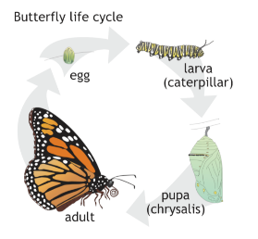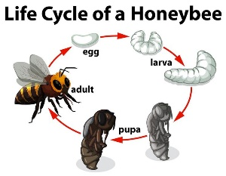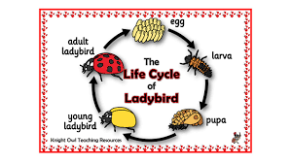  We are also looking at different parts of the plants using the vocabulary root, stem, bud, petal, flower. |  |   Parents Hints and Tips  Coats & Sunhats  Please ensure children have a waterproof coat and a sunhat everyday. Please apply sun lotion if needed - dependent on the forecast.  We are outside regardless of the weather.  Thank you

