English  This week we will be reading the book Peace at Last and looking at instructions. What are instructions and looking at examples. The children will then be writing their own instructions. | Maths  This week in Maths we are ordering numbers from smallest to greatest and greatest to smallest. To solve problems using the inequality symbols | PE  Our focus in PE in this half term will be multi-skills Please ensure your child has a full, named PE kit including joggers.
Music  We will be rehearsing our Harvest Festival Songs. We will be thinking about using our voices to create an effect. | Week beginning 28.09.25  Incredible Me!  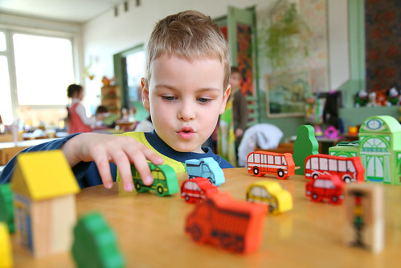 | Science  We will be looking at our different senses.
Poetry  We will be looking at classic Poems from our “Poetry Basket”. |  | Art  This half term we are going to be looking at sketching and mark making in Art and using H and B pencils to create different effects.
 | PSHE  This half term we are focusing on safety at home. This week we will start thinking about what is/is not an emergency. | Geography  We will be learning about how to use Goggle Earth and finding out about our local area on a map.
Phonics
We will be recapping and reviewing Basics 4 and reading CVCC words.

