Question of the Week: Do all animals look the same? WB: 18.03.2024
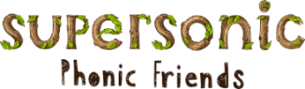  This week we will be revising the spellings for the sounds  oo, oo, or, ar  or, air, ur, ow  We will also be focusing on reading our Tricky Words and our High Frequency Words. The children are aiming to read these words by sight without sounding them out. | In Handwriting, we will be practicing writing Curly Cal letters  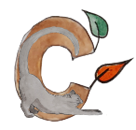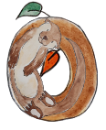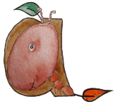  We will be recognising which letter family the letters come from and saying the ditties. | In Writing  we will be practicing writing sentences using the tricky and high frequency words we have been learning this term.  We will also be writing clues about different animals.  . |  | Maths  This week the children will continue to learn about doubles. They will use what they have learnt to explore even and odd numbers.
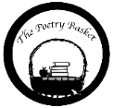  Baby Monkey  Don’t leave your monkey baby sitting  by a swamp.  A crocodile might eat him. Chomp, chomp, chomp.  Don’t leave your monkey baby sitting in the breeze.  A snake might wrap around him. Squeeze, squeeze, squeeze.  Don’t leave your monkey baby sitting on a track.  A lion maybe lurking. Snack, snack, snack.  Keep your monkey baby high in the trees  Feed him on bananas and pick off all his flees. | Our topic is Amazing Animals –  Do they all look the same?  We will be reading the books  Monkey Puzzle, Day Monkey/ Night Monkey and Owl Babies.  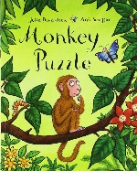  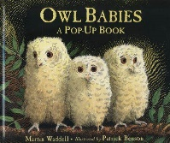  We will continue looking at non-fiction books on animals. |  | Special Visits  Library  Caterpillars – 21st March  Honeybees – 22nd March  Ladybirds – 28th March | Parent Section  Reading.  Please listen to your child read their book, sound strips, tricky words and high frequency words every day and sign to say you have heard them.  It is so important that the children are reading regularly to help them embed and consolidate the learning they are receiving at school.  Thank you
Curious Question

Would it be a good or a bad thing if kittens grew as big as elephants?
