WB: 6.7.25 & 13.7.26 Question of the Week: What can we do to help our world stay wonderful? Reduce, Reuse, Recycle

Core Text  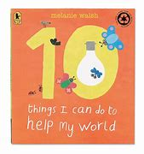 | In Handwriting, we will be continuing to practise writing our spellings for sounds and tricky words.  We will focus on:  - Correct letter formation.  - Letters sitting on the line.  - Tall letters to the top.  - Capital letters are twice the size. | 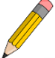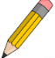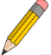  In Writing, we will be focusing and checking how many Basic 3 and Basic 4 words the children are able to read by sight and write independently. | Maths  In Maths, we will be continuing to revise the properties of Plane (2D) and Solid shapes (3D) and making our own.  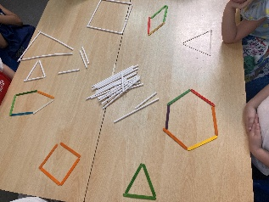
Transition  The children will be going to their new classrooms and spending time with their new teachers on  Tuesday 7th, Wednesday 15th, Monday 20th.  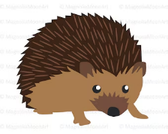  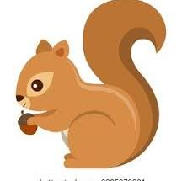  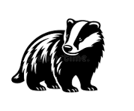 | This week in topic we are learning about recycling.  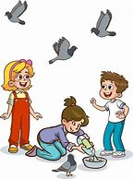    In topic the children will be thinking about 10 things that they can do to help look after our world.  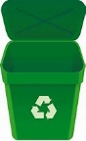  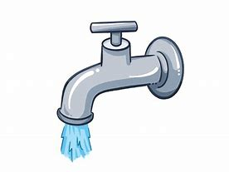  turn lights off turn taps off put litter in the bin feed the birds  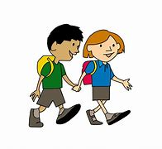  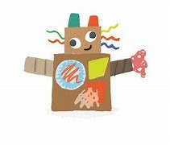    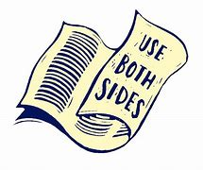  use both sides of paper turn off TV junk modelling walk to school  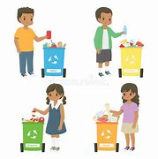  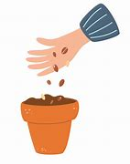  plant seeds sort recycling |  | Parents tips and hints  Please continue to practise reading and writing the sounds and words with your children. The more they practise the better they will be able to recall and write them from memory.  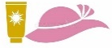  Please can you ensure that your children have sun cream applied before arriving at school and are equipped with a sun hat to enjoy the warm weather

