Question of the Week: What are some of London’s most famous traditions and celebrations? WB: 9.6.25
  In Phonics we will be revisiting ccvcc words for example splash, splat, split as well as chunking words like handstand, desktop, sandpit, windmill. | In Handwriting, we will be revisiting some of the trickier letters to consolidate our learning. We will be practising the ditties and pencil strokes.   |   In Writing, we are looking at famous London Landmarks and writing captions about them using the phrases –  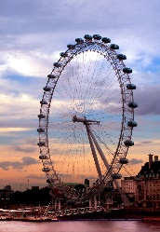  This is  It has  Did you know | Maths  In maths, we will be consolidating learning on subitising, doubling, odd and even and number bonds to 10.  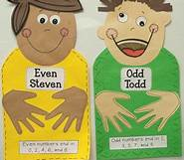
Curious Questions  Would you dare to kiss a frog?  (But what if it would turn into a  prince  or princess?)  Would you rather be a king or  a clown?  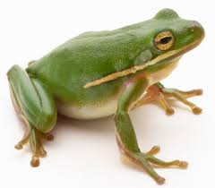 | 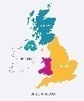  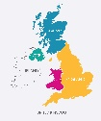  Our topic is Why is Our World Wonderful?  This week we will be learning about London’s most famous traditions and celebrations. We will be reading the following stories to support our learning –  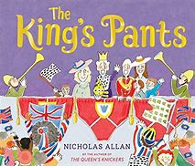  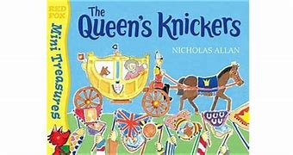  We will be visiting St Mary’s Church to learn about the different features of a church and to find out more about a Christian Wedding ceremony. |  | Dates  Friday 27th June – Sports Day  (4th July – Reserved Sports Day)  Friday 4th July – Summer BBQ  Thursday 10th July – Open Evening  Wednesday 16th July – Honeybees Celebration Performance  Thursday 17th July – Caterpillars Celebration Performance  Friday 18th July – Ladybirds Celebration Performance

