PE  Gymnastics  Mindful minutes  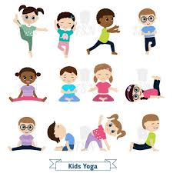 | ENGLISH  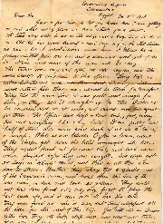  .  This Photo by Unknown Author is licensed under CC BY  Children to continue the genre of letter writing by showcasing the skills they have built up over the unit.  HANDWRITING  Focusing on flicks ready to start joining and number thirty one 31  PHONICS  Daily Phonics Sessions.  READING  Daily Story Sessions & Learn a Poem.  Remember to bring in reading books / Reading diaries every day. Please sign the diary when you have heard your child/ren read.  Supersonic Phonics Friends  Support Sheet | 9.2.25  We will continue to focus on our school Behaviour Expectations & Values.  We will be reading:  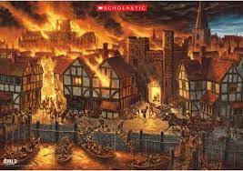  The Great Fire of London Non-Fiction & Stories | MATHS  Subtraction, Position and Direction Quizzes & Column Subtraction & Investigation.  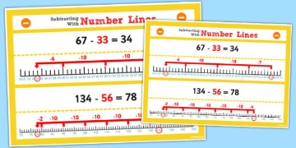 | MUSIC  A focus on singing expressively, playing tuned musical instruments, creative composing, responding to pitch changes and playing, creating and performing rhythmic patterns.  
SCIENCE  We will be looking at Materials.  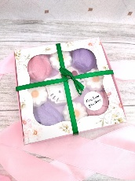  Bath Bombs Investigation |  |  | HISTORY / ART/ COMPUTING  The children will be looking at primary & secondary sources. Also they will be looking at the change in Monarchy in 1666 to present day.  They will continue to creating Powerpoint Presentations on the Great Fire of London.  Great Fire of London Afternoon a celebration of our knowledge!  
PSHE  Behaviour Expectations & Values  Reflection  Circle Time   |  | Homework    New homework will be issued after Half Term. | FINE & GROSS MOTOR  Funky Fingers  Crossing the mid-line.  Further developing of cutting skills.  

