WB: 17.11.245 | Value: Collaborate | Behaviour Expectation: Do be kind and helpful
Question of the Week: How Do Colours Make Me Feel?

We will be reading the story:  The Colour Monster  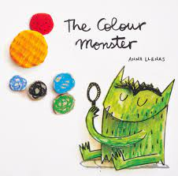  https://www.youtube.com/watch?v=aBPFplfLvZo | Grandma’s Fantastic Words  upset confused/all over the place muddled  clear understand comprehend    Please use these words in a variety of different contexts and encourage children to use them.: |  | Poetry Basket Poem  Carrot Nose  A cute little snowman, with a  long carrot nose,  Along came a rabbit, and what  do you suppose?  That cute little rabbit, looking  for his lunch,  Ate the snowman’s carrot nose,  Nibble, nibble, munch! | Please share Library Book Club  
Curious Conversations:
How do colours make you feel? I agree because…I disagree because…
Phonics  We will Oral blending touch your t-oe-s etc point to your b-r-ai-n  We will be learning to write the spellings for the sounds:  g o c k  We will be learning to write the tricky words to and the and the high frequency words on, can, got, not  Please see Phonics Home Learning for further details |  | Our value this week is -  Collaborate    To work with someone else, or a group, to achieve or do something  The children will demonstrate in a variety of ways different levels of collaboration throughout their learning this week including .  Our behaviour expectation this week is: Do be kind and helpful. |  | Spoken Language  We will be asking children to describe things using colour – the red pencil, the green frog.
Drawing Club
This week we will start Drawing Club. In Drawing Club sessions, children will create illustrations that stem from inspired well-loved stories. The approach supports children to express themselves freely while building literacy, language, and artistic skills. The emphasis is on joy, imagination, and the process of discovery,
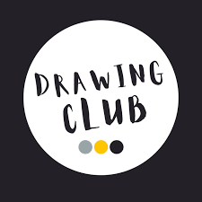

The Zones of Regulation.  The Zones of Regulation is a framework designed to help children and adults understand and manage their emotions and behaviour. It categorises emotions and states of alertness into four color-coded "zones," each representing a different level of self-regulation: green zone, blue zone, red zone, yellow zone. The zones help individuals recognise their emotional state and employ specific tools or strategies (e.g., deep breathing, taking a break) to move toward the green zone, where they are best able to learn and interact positively. This approach fosters self-awareness, emotional vocabulary, and self-regulation skills.  Green is for calm, happy balanced, ready to learn. You are good to go.  I am feeling good, I can play and learn, I can help a friend, I can try new things, I can practise my calming strategies when I need them most  Red is for mad/angry/ frightened/ terrified (need a strategy -)  Strategies include:  Walking away, stop what I am doing, being safe, asking for help, going into the quiet area. Stop and gaining control by  Breathing smell the flowers and blow out the candles, touching fingers - I feel calm now  Blue is for sad/unhappy/poorly/ tired/bored (need a strategy)  Strategies include:  Stretching, going for a walk, drinking some water, talking to someone you trust, thinking about something that makes you happy. Rest and Recharge.  Yellow is for worried/excited/frustrated (need a strategy)  Strategies include:  Count to 10, take deep breaths, go to a safe space, play with a fidget toy, draw, write or talk about it. | Feelings Pictures  We will give the children the opportunity to create pictures based on colours and feelings. Children will have the choice of a range of materials and colours to make their own creations. | Maths Part Whole  In Early Years Foundation Stage (EYFS), the "part-whole" concept helps children understand that numbers can be split into smaller parts and reassembled into a whole. For example, the number 5 can be divided into parts like 2 and 3 or 4 and 1. This concept builds foundational number sense, enabling children to see relationships between numbers and develop skills for addition and subtraction. Through activities with objects or visual aids, children explore how numbers are made up of different combinations, reinforcing their understanding of number structure and flexibility in mathematical thinking.
We will practising writing g o c k

 | 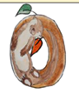
Curl around the gorilla’s body, down and round his arm | Around with the otter
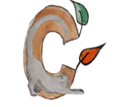 | 
Curl around the cat | Down one arm to his toes, around his head and out to his nose.

We will re-read Peace at Last by Jill Murphy and compare day and night.
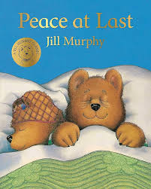
We will be comparing the brightness of light sources and exploring shadows.
