PE  Gymnastics  Mindful minutes   | ENGLISH  Writing linked to Growth Mindset  HANDWRITING  Number Handwriting and words containing Curly Cal, Lens Ladder or Zig Zag Letters  PHONICS  Daily Phonics Sessions  READING  Daily Story Sessions including Helicopter Stories, Tales Toolkit Stories and Talk for Writing & Learning Poems.  Remember to bring in reading books and diaries every day. Please sign the diary when you have heard your child/ren read. | 20.10.25  This week it is…  Growth Mindset Week  We will be reading  After The Fall  Rosie Revere Engineer  What Does ‘Growing Our Brains’ Mean? | MATHS  Number  Revision and consolidation of knowledge and recognition of number, place value and counting in 2s, 5s and 10s.  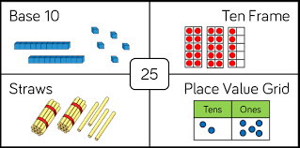 | MUSIC  Songs & rhymes  
COMPUTING



E-safety & Laptops
GROWTH MINDSET ACTIVITIES AT SCHOOL  What is Growth Mindset?  The Power of Yet  Learning from Mistakes / Learning Opportunities  Perseverance  Resilience  Celebration of Learning  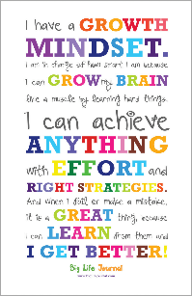 | PSHE    Reflection on the half term  Loving to Learn & Growth Mindset | GROWTH MINDSET ACTIVITIES AT HOME  Perhaps your child/ren could do the following at home to model Reflection:  Create a Growth Mindset Collage with positive affirmations and drawings  The Magic of Yet – Add the word ‘yet’ to statements to emphasise that skills can be learnt with effort  3 Try Drawing / Building Challenge – set a timer for a short period, have children try to complete a task (like drawing an animal) and then try again from scratch to see how their skills improve with practice  Growth Mindset Yoga (Grow-Ga) – combine simple yoga poses with growth mindset statements | Homework    New homework was issued on 9/10/25 and needs to be returned by 21/10/25.  They need to find and write and decorate their own autumn poem.  There will be no homework set for Half Term. | FINE & GROSS MOTOR  Funky Fingers:  Cutting Skills  Crossing the mid-line  

