English  We will looking at instructions and using ‘so’ to join clauses. Our book we will read is called | Maths  We will be learning to count in 2, 5 and 10s. This will be done practically and through classroom based activities. | PE  Our focus in PE in this half term will be multi-skills Please ensure your child has a full, named PE kit including joggers as we will sometimes be outside.
Music  We will be exploring musical sounds and how they can be changed focussing on timbre, dynamics and pitch. | .  Week beginning 27.4.26  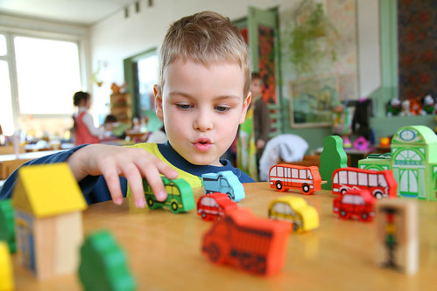 | Science  This week we will be learning about trees, identifying and describing them.
Poetry  We will be looking at classic Poems from our “Poetry Basket”.  This half term our poems are “Animals” |  | Art  We will be looking at the artists; Damien Hirst and completing different printing activities.
 | PSHE  This half term we are focusing on Me and My Family. | History  We will be looking at finding ways in which air transport in the past is similar and different to now.
Phonics  We will be working through the Switch it Mitch sounds and tricky words. | PSHE  This half term we are focusing on Me and My Family.

