Question of the Week: Do all minibeasts stay the same? Mini Beasts – Life Cycles WB: 29.04.24
In Phonics we will be focusing on learning how to write words using the following spellings for the sounds  oo oo ar or  Please continue to revisit the previous phonic sheets sent out. | In Handwriting,  we will be continuing to practise writing our Basic 2 and 3 tricky words and high frequency words.  We will be learning how to form the spellings for the sounds  v w  We will be recognising which letter family the letters come from and saying the ditties as we practice! | In Writing,  we are learning to retell the story of the ‘Hungry Caterpillar’. We will innovate the story and create a story map.  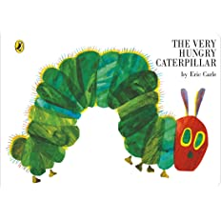 | Maths  In Maths, the children will be exploring the composition of numbers from 1 – 9 using the ‘5 and a bit’ model.  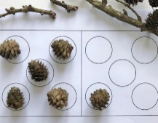  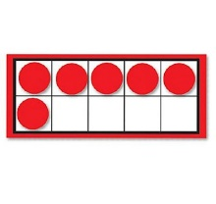
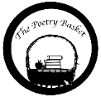  I Have a Little Frog  I have a little frog,  His name is Tiny Tim,  I put him in the bathtub,  To see if he could swim.  He drank up all the water,  And gobbled all the soap.  And when he tried to talk,  There were bubbles in his throat.  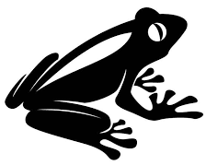 | Our topic is Nature Detectives – Life Cycles  We will be reading  During our daily story times we will be enjoying some of the following stories: The Hungry Caterpillar, Crunching Munching Caterpillar, Growing Frogs and The Tweeny Weeny Tadpole.  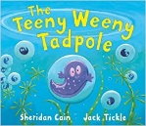  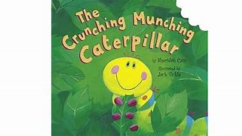  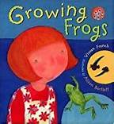  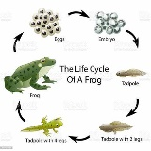  In topic we will be learning a variety of songs to familiar tunes to  help us remember the different mini beast lifecycles.  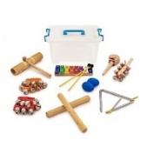  This week the children will be learning about lifecycles. In particular, we will be thinking about the lifecycles of frogs, caterpillars, honeybees and ladybirds. |  | Parents Hints and Tips  Reminder  On Wednesday PE will be held outside, please could you ensure that your child is well equipped with a full PE kit, e.g. jogging bottoms and hoodies just in case the weather is a little chilly.  Coats & Sunhats  Please ensure children have a waterproof coat and a sunhat everyday. Please apply sun lotion if needed - dependent on the forecast.  We are outside regardless of the weather.

