WB: 23.2.26 | Arts Week

Arts Week is based on the book Tell Me A Dragon by Jackie Morris  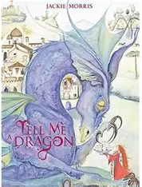  We will be exploring clay modelling linked to the book. | Drama Workshop  We are very lucky to have a Drama Workshop as part of our Arts Week.   | Tales Toolkit  We will be continuing to create class Tales Toolkit using symbols. We will be substituting But for Unfortunately and So for Fortunately Can you make up a story at home? Remember to use the sentence starters
   | One upon a time/ A long time ago there was a ……. who lived in …………  One day……  Unfortunately …..  Fortunately …..  Snip snap snover, the story is over. Snip snap snout the story is out/ Tap the nail the nail bends, this is how the story ends.
  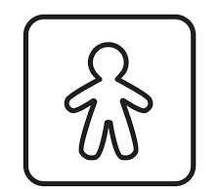
  
  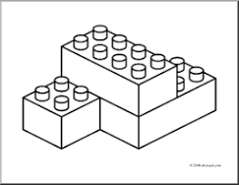
  
  
Music

We will be learning lots of new songs as part of Arts Week.


Phonics  We will be learning to write the spellings for the sounds:  ear, air, ure  Tricky words: little, out  Please see Home Learning for further details. | Please share Library Book Club  

