English  This week we looking at writing a recount, writing sentences with a full stop and capital letter. | Maths  We will be looking at place value to 20. | PE  Our focus in PE in this half term will be multi-skills Please ensure your child has a full, named PE kit including joggers as we will sometimes be outside.
Music  We are going to be looking at rhythm. | Week beginning 5.1.26  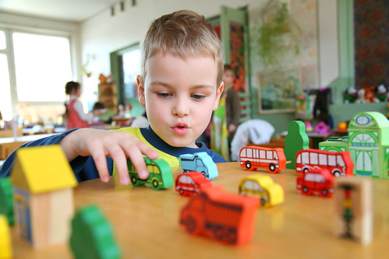 | Science  This week we will be looking at the materials different toys are made from.
Poetry  We will be looking at classic Poems from our “Poetry Basket”.  This half term our poems are “Space” |  | Art  This half term we will be working on mixing of primary colours.
 | PSHE  This half term we are focusing on looking at feelings and how to regulate your own feelings. | History  This week we will start looking at a selection of new and old toys.
Phonics
We will be working through the choose to use sounds and tricky words.

