Autumn 1 Week 6
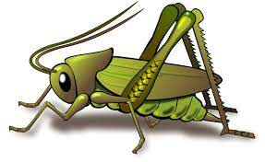
Value of the week: Independence
Activities based on the interests of the children….
Our story  This week our core text is You Be You .  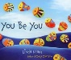  This story supports our learning of the school value Independence and of our school behaviour expectation of Do be Honest.  We will also continue to read familiar stories from our classroom. | Poetry basket  We will be listening to stories, rhymes and fairy tales.  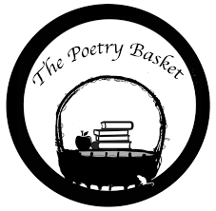  We will continue to learn our third poem. See if your child can recite the two poems that we have already learnt. They are called Chop Chop and Wise Old Owl.  Our Poetry Basket Poem this week is:  Falling Apples  Here is the tree with its leaves so green.  Here are the apples that hang in between.  When the wind blows, the apples will fall.  And this is the basket to catch them all. | Phonics  We will be continuing to use our listening ears by playing lots of games. We will be making sounds with everyday objects and guessing what is inside the box.  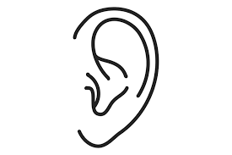
Maths  This week our Number Rhyme is 5 little ducks.  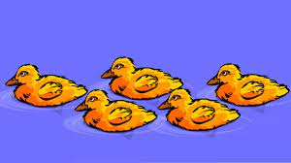  We will continue to subitise groups of objects (0-3). We will practice trying to say how many things we can see without counting.  “What do you see? How do you see it?” We will be encouraging the children to represent their Maths by mark making.  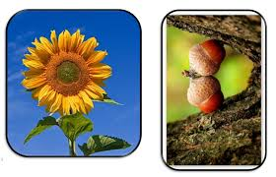 | Our value of the week  Our value this week is: Independence.  Our behaviour expectation this week is: Do be honest.  We will also be continuing to learn about how to look after our classroom and each other, to work hard, to be kind and helpful and to be polite and gentle.  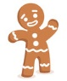 | Mark making  We are continuing to develop our gross motor skills with our ‘Squiggle while you Wiggle’ dance. We will be practising our mark making whilst we play. We will be practising the below patterns.  | ------ S  We will also be continuing to make different marks outside using large up/down and across movements whilst using the water brushes, chalks, sand, and in the air with noodles and scarves.

