Question of the Week: How many creatures find their homes in the Foundation Stage garden? WB: 27.4.26
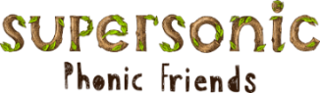  In Phonics we will be continuing to segment and blend CVCC words.  We are continuing to learn our  High Frequency Words and Tricky Words by sight | In Handwriting, we will be writing:  v,w,x,z  We will be ensuring that our letters are the correct height and are formed correctly. |   In Writing, we will be writing sentences about Minibeasts that include the spellings for the sounds, high frequency words and tricky words that we are learning and revising.  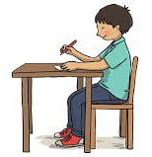 | Maths  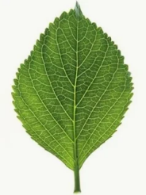  The children we will be learning Number Bonds to 10, and continue to extend their learning on length, collecting natural objects and measuring them to see which objects are longer than, short than or equal to each other.  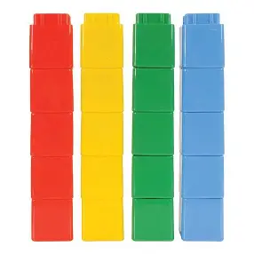
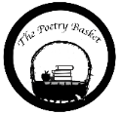  Under a Stone  Under a stone where the earth was firm,  I found a wiggly, wriggly worm.  “Good morning,” I said.  “How are you today?”  But the wiggly worm just wriggled away.  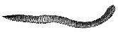 | Our topic is ‘Nature Detectives’ – Mini Beasts  We will be reading –  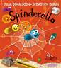  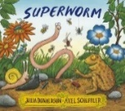  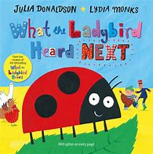  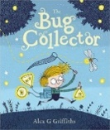  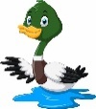  We will be looking at nature in the environment. In particular, wild life on the canal and mini beasts in the garden. We will visit our bug hotel. |  | Parents Hints and Tips  Coats & Sunhats  Please ensure children have a waterproof coat and a sunhat everyday We are outside regardless of the weather.  Please apply suncream before your child comes to school. Thank you.

