  - Question Of The Week: How do I keep myself healthy? WB: 06.11.22
We will be looking at information books about how  to keep ourselves healthy.  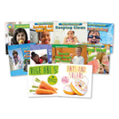 |  | We will be reading stories about keeping ourselves healthy and about healthy foods.  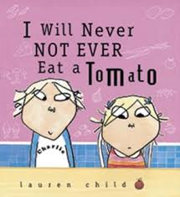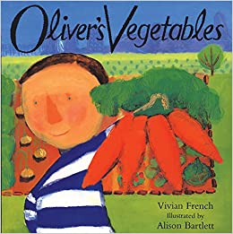 |  | We will be talking about Oral Health and how to keep our teeth healthy and clean.  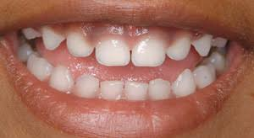
We will be talking about different fruits and vegetables and making our own fruit kebabs for snack as well as tasting different vegetables  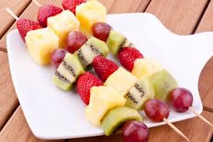 |  | We will be learning about different people who help us to keep healthy including Doctors, Nurses and Paramedics, Dentists and Opticians.   |  | We will be learning about the effects exercise has on our bodies and other ways we can keep our bodies and minds healthy.  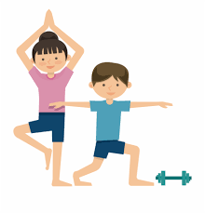  The children will be participating in daily exercise, so please can they be dressed in appropriate clothing and footwear to join in comfortably.
Phonics and Handwriting  We are continuing to learn our tricky words and practise learning and writing our sounds. We are learning to write the sounds i, n, m, d. | 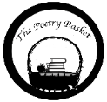  Popcorn  Popcorn, Popcorn, sizzling in the pan.  Shake it up, shake it up,  Bam, Bam, Bam.  Popcorn, Popcorn, now it’s getting hot.  Shake it up, shake it up,  Pop, Pop, Pop |  | Remembrance Day  We will be finding out why we celebrate Remembrance day and the significance of wearing poppies.  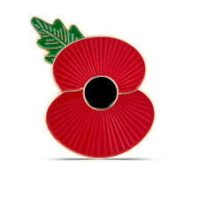 |  | Parents Tips and Reminders  - Children should come to school wearing sports clothes every day this week, ready to take part in our health week activities.  - Please ensure children bring their reading books every day to school.  Thank you

