THE JOHN HAMPDEN SCHOOL WENDOVER – SCHOOL UNIFORM ORDER FORM

CHILD’S NAME ……………………………………………………………………………………………………………………………………………..………………………….

Item |  | Price | Quantity | Size | Colour  (Please state which colour you would like) | Total cost
Navy Fleece (age 3/4, 5/6, 7/8 with logo) | 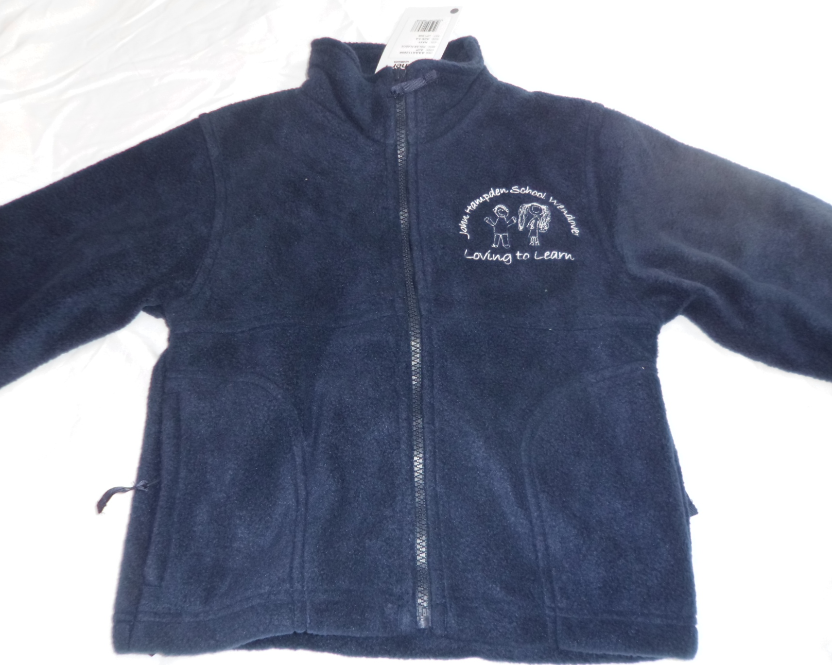 | £15.00 |  |  | Navy
Navy Sweatshirt with logo (24”, 26”, 28”, 30”, 32”) | 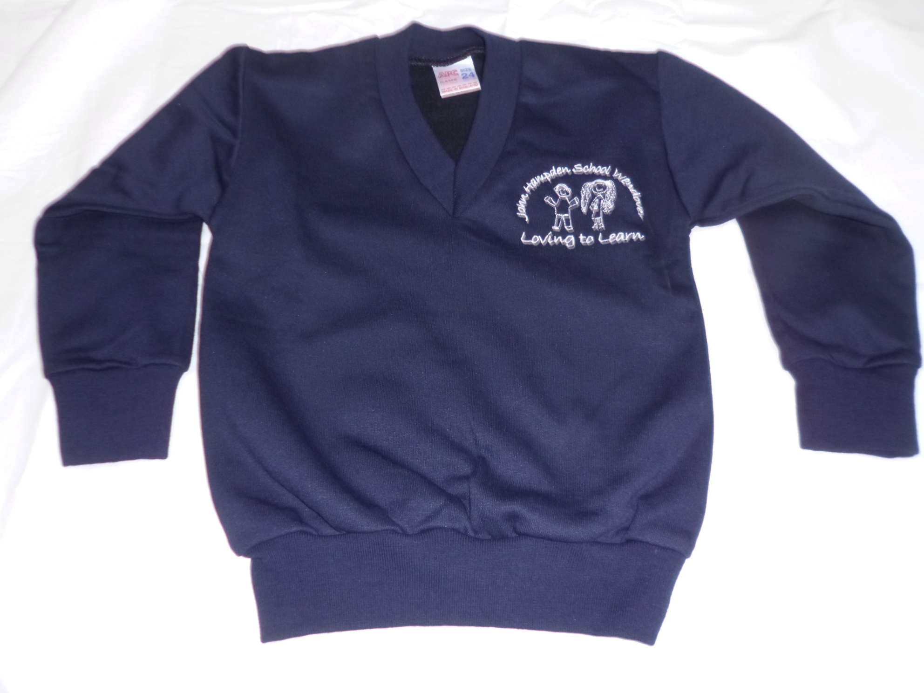 | £12.50 |  |  | Navy
Navy Sweatshirt Cardigan with logo (24”, 26”, 28”, 30”) | 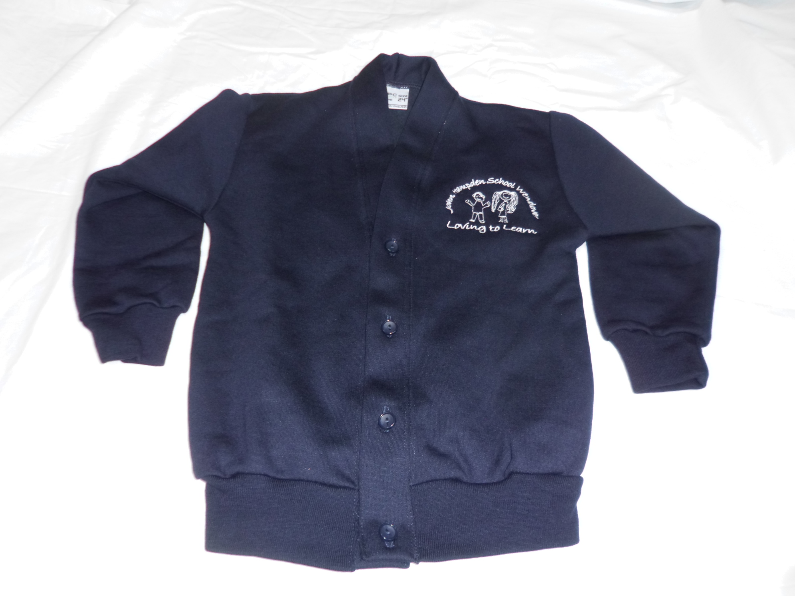 | £13.50 |  |  | Navy
White polo shirt with logo (age 3/4, 5/6, 7/8) | 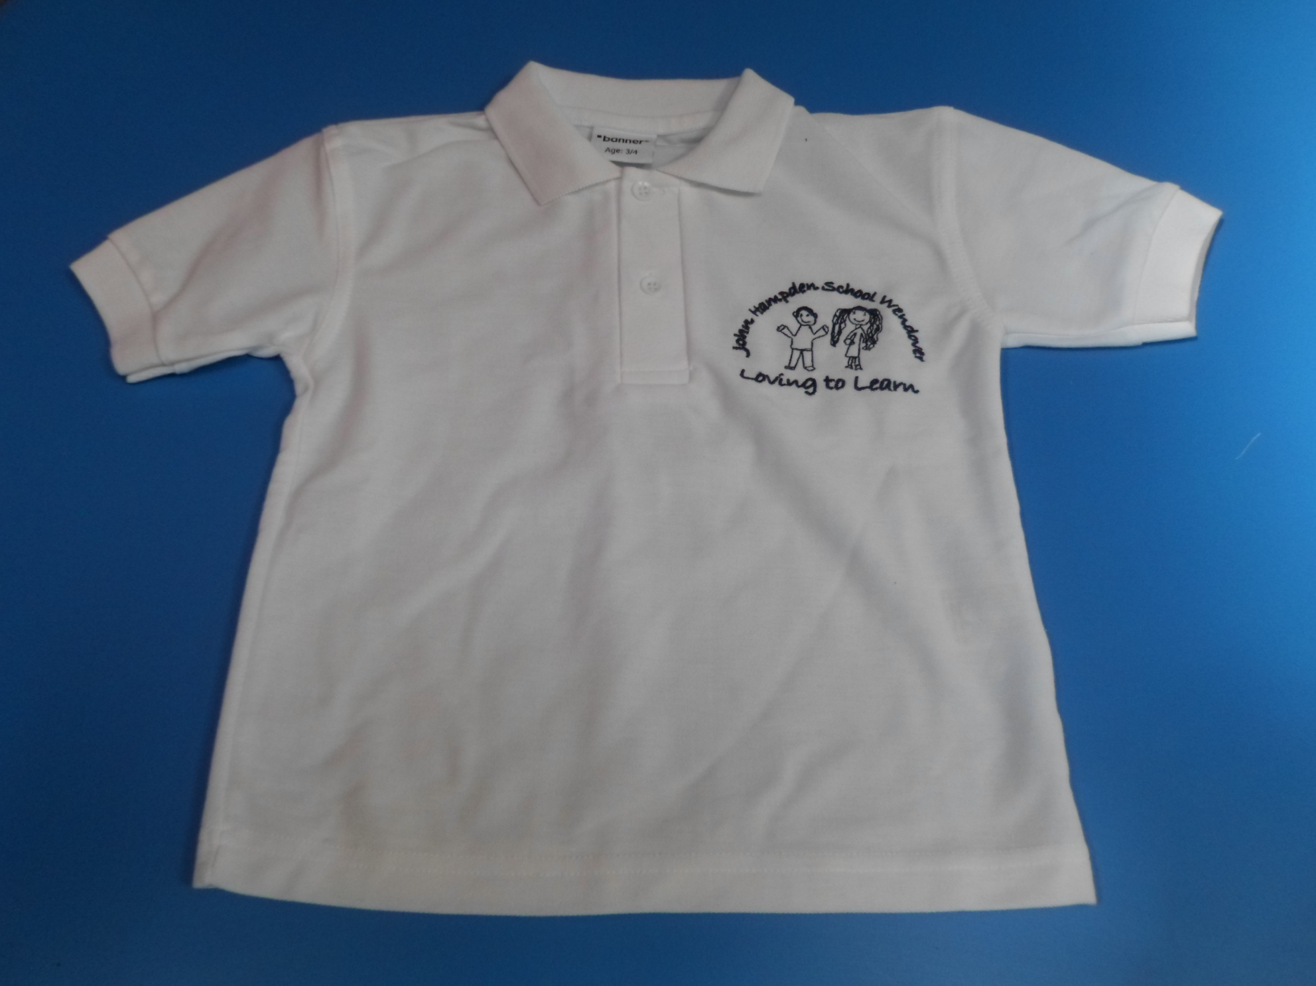 | £9.50 |  |  | White
White PE t-shirt with logo (age 3/4, 5/6, 7/8) | 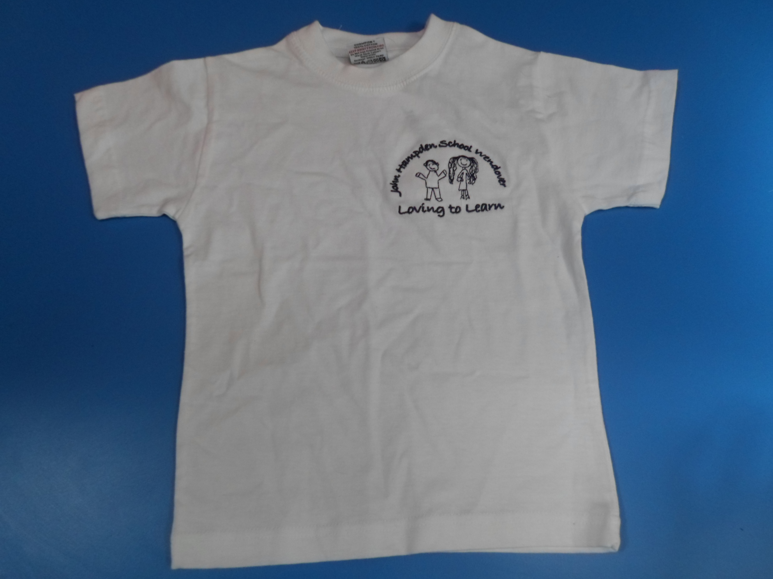 | £7.00 |  |  | White
Navy PE shorts (22, 24”, 26”, 28”) | 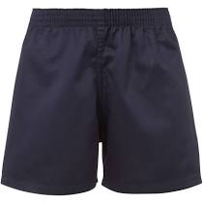 | £7.00 |  |  | Navy
PE bag (black, red, pink, purple, royal blue, navy, emerald green, bottle green, yellow, orange, jade)  PLEASE STATE COLOUR | 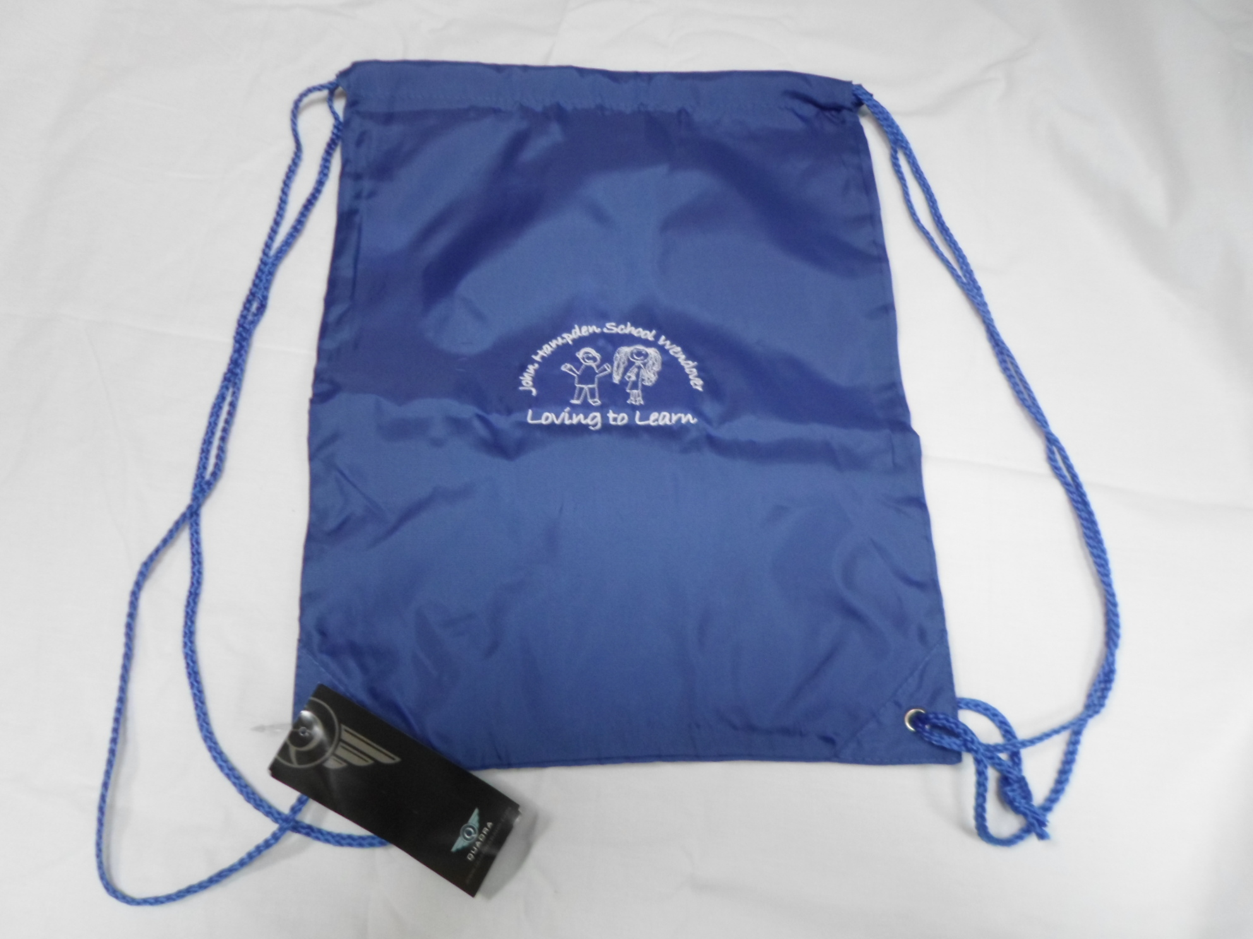 | £5.00
Waterproof reading folder/book carrier with logo (purple, navy, black, red, emerald green, royal blue, bottle green, jade, yellow)  PLEASE STATE COLOUR | 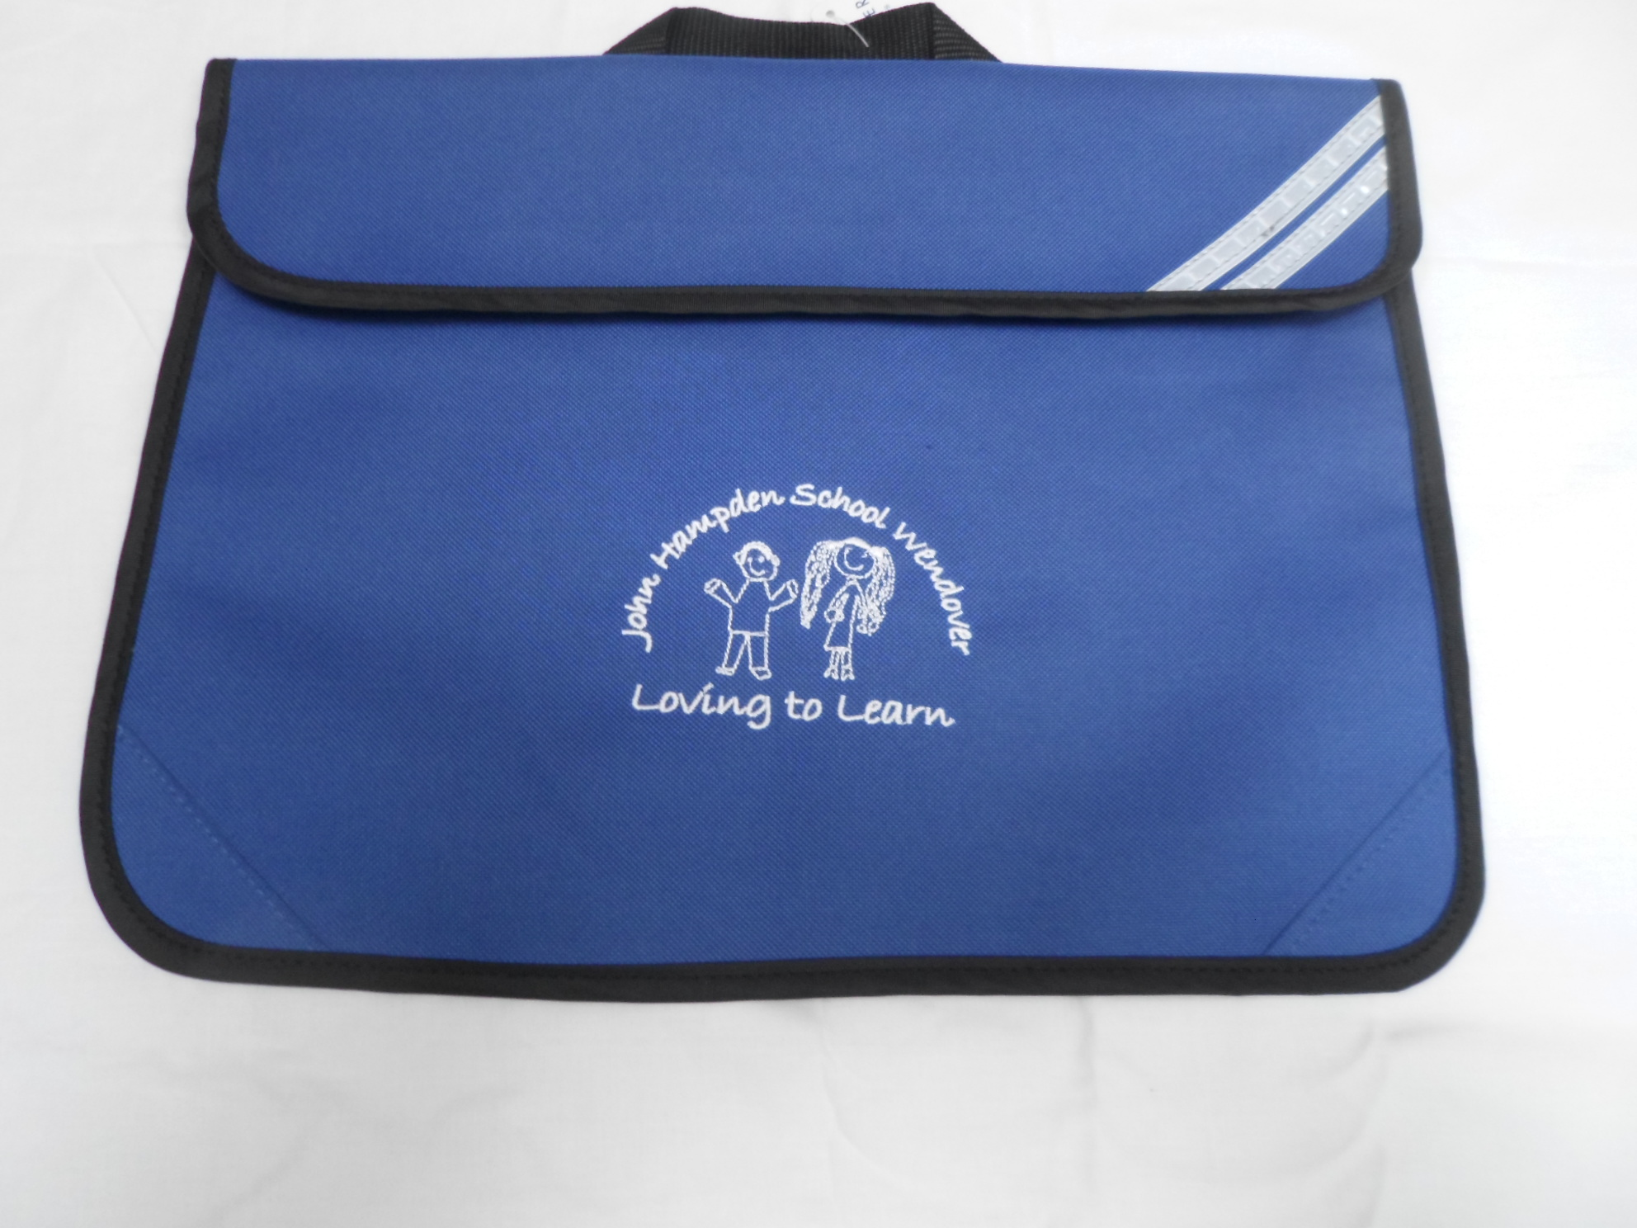 | £6.00
Woollen hat with logo (navy blue) – one size | 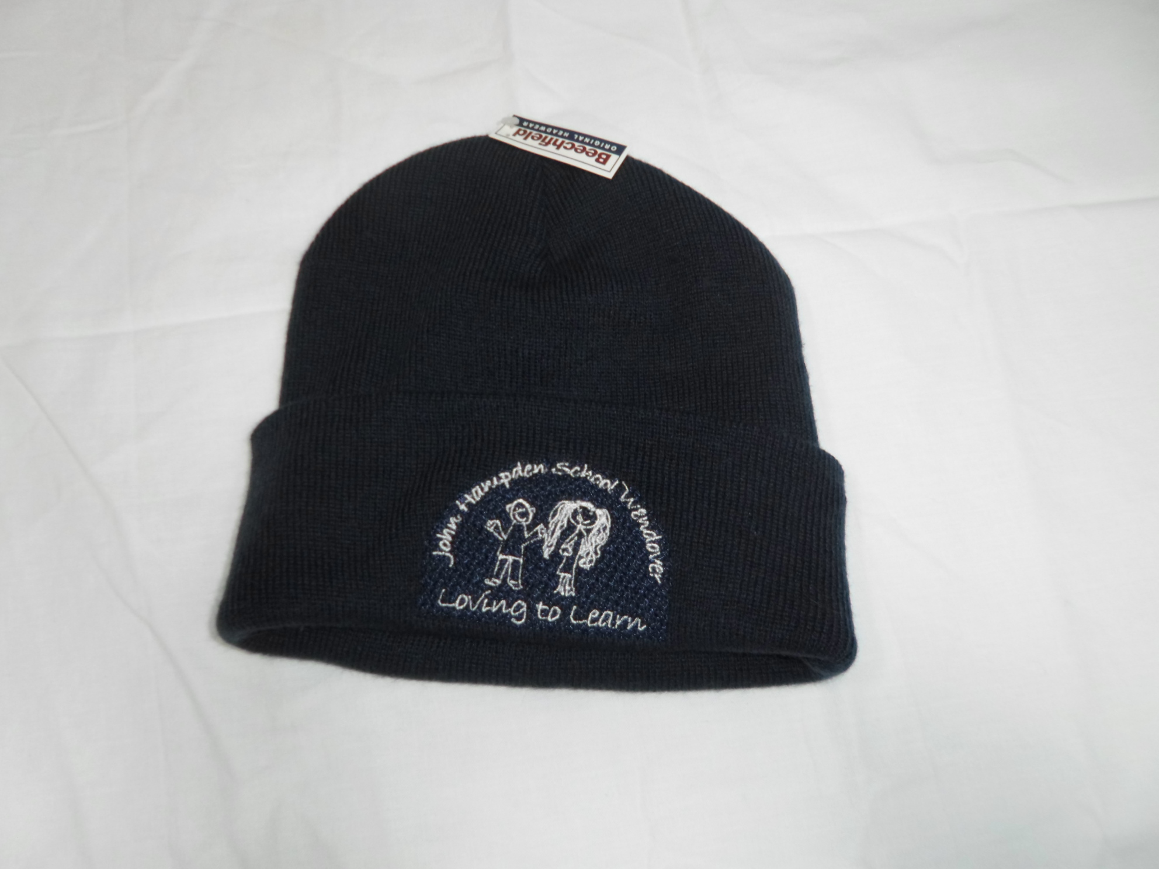 | £5.00 |  |  | Navy
Boys grey trousers (age 3/4)  (Phasing out – short supply of stock) | 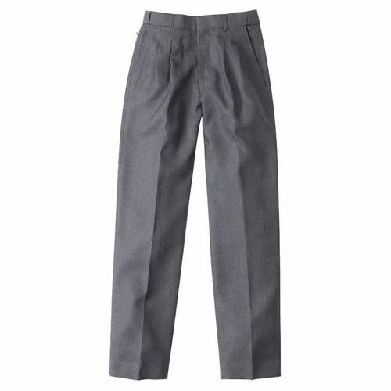 | £5.00 |  |  | Grey
 | TOTAL |  |  |  |  | £

PLEASE MAKE PAYMENT ONLINE (BANK DETAILS ARE:- LLOYDS BANK, SORT CODE 30-90-38, ACCOUNT NUMBER 00943838, REFERENCE = UNIFORM)
PLEASE STATE ON YOUR ORDER FORM WHEN YOU HAVE PAID ONLINE AND PLEASE ENSURE YOU STATE PAYMENT IS FOR UNIFORM IN THE REFERENCE FIELD ONLINE.

