Question of the Week Why do people celebrate Easter? WB: 25.03.2024
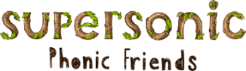  This week we will be revising the spellings for the sounds  ur ow oi er  ure ear air  We will also be focusing on reading our Tricky Words and our High Frequency Words. The children are aiming to read these words by sight without sounding them out. | In Handwriting, we will be continuing to practice writing  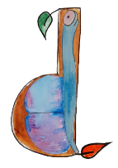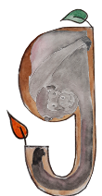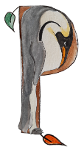  We will be recognising which letter family the letters come from and saying the ditties. | Writing  In Writing we will be practicing writing sentences using the tricky and high frequency words we have been learning this term.  We will also be writing clues about different animals. | Maths  The children will continue to explore the composition of numbers within 10, focusing on the ‘special case’ of when 2 equal parts combine to make a whole (doubling).
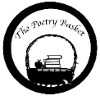  Baby Monkey  Don’t leave your monkey baby sitting  by a swamp.  A crocodile might eat him. Chomp, chomp, chomp.  Don’t leave your monkey baby sitting in the breeze.  A snake might wrap around him. Squeeze, squeeze, squeeze.  Don’t leave your monkey baby sitting on a track.  A lion maybe lurking.  Snack, snack, snack.  Keep your monkey baby high in the trees.  Feed him on bananas and pick off  all his flees. | In topic we will learning about The Easter Story and having fun  creating Easter arts and crafts.  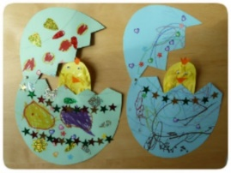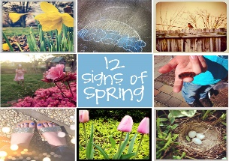  We will also be looking for different signs of spring and reading both fiction and non-fiction books about growing and spring and Easter.  Story for the Week  Our book for the week is ‘We’re Going on an Egg Hunt’ 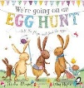 |  | Parent Section  Don’t forget School closes for  Easter Holidays  Thursday 28th March at 1.30pm  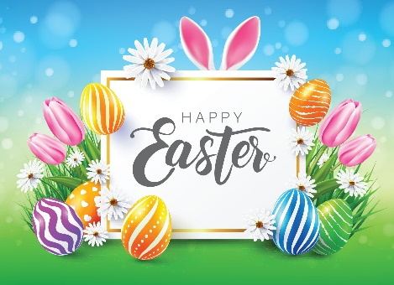  Summer Term starts  Monday 15th April 2023 at 8.45am  Have a lovely break everyone!

