English  This week we will writing a character description using adjectives and similes. | Maths  We will be identifying missing numbers on a number line to 50, reading scales in ones and tens. | PE  Our focus in PE in this half term will be multi-skills Please ensure your child has a full, named PE kit including joggers as we will sometimes be outside.
Music  We will be exploring musical sounds and how they can be changed focussing on timbre, dynamics and pitch. | Week beginning 9.3.26  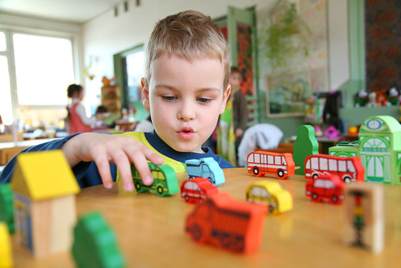 | Science  This week we will be looking at living and non-living things.
Poetry  We will be looking at classic Poems from our “Poetry Basket”.  This half term our poems are “Space” |  | Art  This half term we will be working on mixing of primary colours.
 | PSHE  This half term we are focusing on friendships, diversity and communities.  Our value of the week is independence. | Geography  We will be going on our Wendover walk. Following a map, using directional language.
Phonics
We will be working through the Switch it Mitch sounds and tricky words.

