Question of the Week: Do all minibeasts look the same? WB: 04.5.26
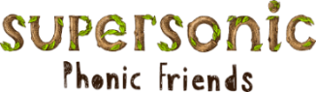  In Phonics we will be continuing to segment and blend CVCC words.  We are continuing to learn our  High Frequency Words and Tricky Words by sight | Lifecycles  We will be learning about lifecycles of different animals  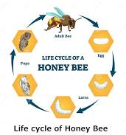 |   In Writing, we will be creating a story wheel based on the Hungry Caterpillar.  We will choose our own character and food.  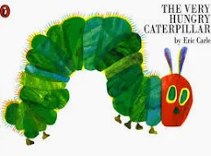 | Maths  We will be learning about symmetry. We will look at symmetry in shapes as well as objects  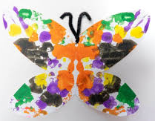
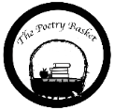  I had a little frog  I had a little frog,  His name was tiny Tim  I put him in the bath tab  to see if he could swim  He drank up all the water  And gobbled up the soap  And when he tried to talk  He had b…b…bubbles in his throat! | Our topic of ‘Nature Detectives’ continues  We will be reading –  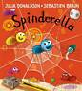  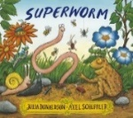  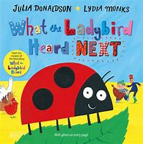  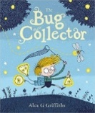  We will continue looking at nature in the environment, trying to spot Minibeasts around us. |  | Computing  We will be learning to create algorithms to program Beebots.  