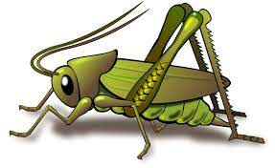
Spring 2 Week 6
Theme of the week – Easter
Activities based on the interests of the children….
This week we will be reading the Easter Story and other related texts. We will be thinking about how we celebrate Easter and we all differ in our celebrations.  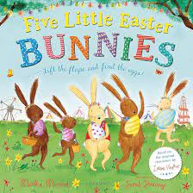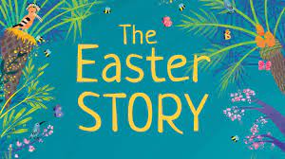 | Our poem this week is called:  A Little Seed  A little seed for me to sow,  A little soil for it to grow.  A little hole, a little pat,  A little wish, and that is that.  A little sun, a little shower,  A little wait, and then a flower.   | We will be thinking about Easter this week and making lots of fun Easter crafts and activities.  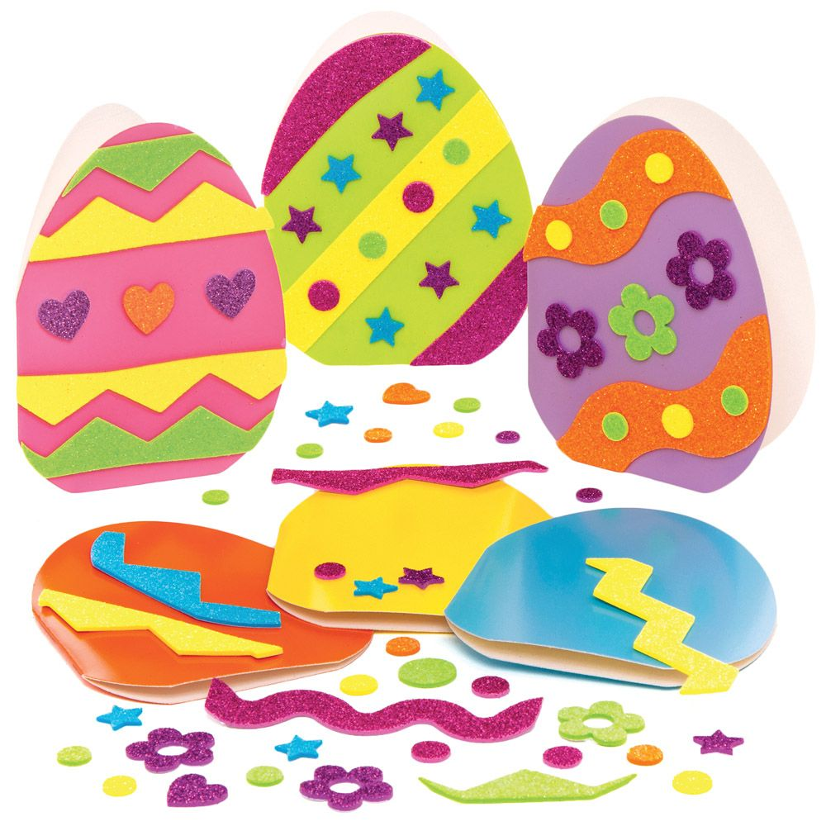  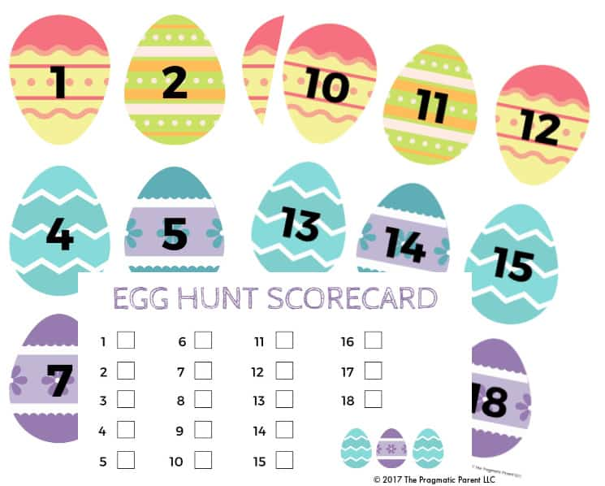
This week’s number rhyme is ’10 Easter Bunnies’  Our Nursery rhyme this week is ‘Sleeping Bunnies’ and ‘Rock a bye baby’  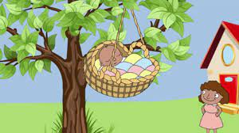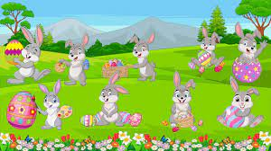  We will be playing Bunny Bunny Hop. |   This week we will be continuing to develop our ‘Phonological Awareness’ by listening to “robot talk” for a word and then identifying the correct word. E.g. I say c -a – t. Can you point to that picture?  Ideas for phonic activities at home:  When you are asking your child to do something, break down one of the words, but ensure it only has 3 parts. E.g. Can you pull up your z – i - p?  Can you get your c – oa –t ? | ‘What do you see? How do you see it?’  We are securing our number sense by subitising numbers to 5, reciting and reordering numbers 0-10, finishing the 5 on the five frame and developing our knowledge of part/whole.  