Question of the Week: How many different animals are in our world? WB: 2.03.2026
  This week we will be revisiting the sounds  j, v, w, x, y, z, zz, qu,  ch, sh, th, ng  Tricky and High Frequency Words  Recap of all HFW and TW taught | Grandma Fantastic  Words  Running chasing hunting  Walking strolling rambling |   In Writing we will be going on a ‘jungle’ expedition and describing what we see. Our sentences will be ‘This is a…, It has…, It can…’.  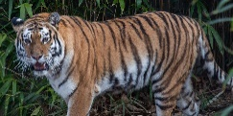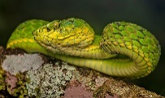 | Maths  We will be exploring equal and unequal groups and thinking about what odd and even means  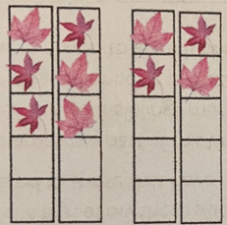
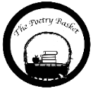  Pancakes by Christina Rossetti  Mix a pancake,  Stir a pancake,  Pop it in the pan.  Fry a pancake,  Toss a pancake,    Catch it if you can. | 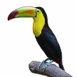  Our topic is Explorer, Explorer – Animals  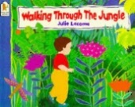  Walking Through The Jungle  What animal am I?  We will be thinking about the features of an animal, for example what animal has orange and black stripes and big teeth? We will be exploring a range of non-fiction books about animals and their habitats.  Where do I live?  We are looking at where different animals live and their habitats, and why they might need to live there, and not in other places. What would happen to a polar bear in the Savannah? Or a lion in the ocean?  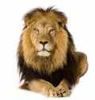 |  | Art - Observational Drawing  This week we will be engaging in some observational drawings of wild animals.  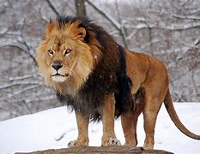  World Book Week  See separate letter but don’t forget to dress up on Friday!  